Task Flow: An Automated Multi-Environment CI/CD Pipeline on Azure
Unit: SWE40006 Software Deployment and Evolution
Group: AeroDeploy
Tutorial: Tuesday, 10:30 am, EN310
Tutor: Jun Han
Submission date: [Insert submission date]
Team member | Student ID
Abhinav Sijy | 105337787
Aditya Suthar | 105056888
Mohita Mittal | 105315657
Unna Nusen | 105214178

Table of Contents

1 - Project Definition & Background 4
1.1 Project Background, Goals and Application Overview 4
1.2 Scope and Evaluation Targets 5
2. Pipeline Design & Toolchain Evolution 6
2.1 Architecture and Deployment Strategy 6
2.2 Toolchain, Configuration and Alignment with the Brief 7
3 - Level-by-Level Implementation & Evidence 10
3.1 Level 1: Pipeline Infrastructure 10
3.2 Level 2: Instrumentation & Monitoring 15
3.3 Level 3: Application Deployment & Verification 20
3.4 Level 4: Full Pipeline Automation 32
4. Troubleshooting & Problem Resolution 33
4.1 Docker Compose Configuration 33
4.2 Container Permission Errors 33
4.3 Projects Page Rendering Error 35
4.4 Automated Test Assertion Failure 35
4.5 Evidence Capture and Repository Checks 36
4.6 CI/Build and Test/Staging Troubleshooting 36
4.7 Production Deployment and Monitoring Troubleshooting 36
4.8 Outstanding Team Issues and Resolution Status 39
5. Project Outcomes & Reflections 39
5.1 Application Development and Local Verification Outcomes 39
5.2 Lessons Learned from Application Development 39
5.3 Scope of the Current Results 39
5.4 Test/Staging and End-to-End Acceptance Outcomes 40
5.5 Pipeline Automation and Performance Evaluation 40
5.6 Production Deployment, Monitoring and Reliability Outcomes 40
5.7 Overall Team Reflection and Future Improvements 40
6. Link to Project Repository 40
References 40
Appendix A: Selected Local Application Logs 41
A.1 Development Environment and Workspace 41
A.2 Container Runtime and Build 41
A.3 Database Schema and Automatic Migration 42
A.4 Local Metrics Endpoint 42
A.5 Database Recovery and Persistence 43
A.6 Automated Application Tests and Coverage 43
A.7 Troubleshooting and Retesting 44
A.8 Repository Checks and Handover 45
Appendix B: Selected Production and Monitoring Logs 46
B.1 Production Server Setup 46
B.2 Access Controls 46
B.3 Monitoring Configuration 46
B.4 Alert Rules 47
B.5 Live Application Verification 47
B.6 Database Backups 47

1 - Project Definition & Background

1.1 Project Background, Goals and Application Overview
AeroDeploy is a team project focused on building and demonstrating a complete DevOps pipeline for a web application. The aim is to connect source code management, building, automated testing and deployment so that a change can move through a controlled process before reaching users. The project also includes production monitoring to help the team identify problems and check how the deployed application performs.
For this project, we developed TaskFlow, a web application for organising projects and tasks. The application uses Flask for its server-side functionality, Jinja templates for its pages and PostgreSQL for data storage. Users can create projects, add and edit tasks, update task statuses, and delete tasks or projects through a confirmation page. Each task can have a description, priority and optional due date. A dashboard summarises the number of projects and tasks, shows progress by status and identifies overdue work.
TaskFlow provides practical ways to demonstrate the pipeline. Its forms and database operations can be checked through automated tests, while visible changes to its pages can be used to demonstrate a new version reaching production. Because the application stores data, it also allows us to check database connections, schema migrations and whether records remain available after containers are restarted or recreated.
Our completed local work includes the application features, input validation, navigation, responsive layouts, database models and migrations. We configured the application and PostgreSQL to run in Docker, with the application running under a non-root account. The startup process applies database migrations before starting the application server. We also provided health and metrics endpoints to support deployment checks and monitoring.
Local verification showed that the main user flows worked and that stored records survived service restarts and container recreation. The automated suite passed 48 test methods with 99.64% application statement coverage. The application was then merged into the shared repository and delivered through the full pipeline. Each change to main is now tested, built once, verified with browser tests on a separate staging server and deployed automatically to a monitored production server at http://20.70.170.224, where it runs behind Nginx with its own PostgreSQL database.
The project had four main goals. The first was to automate the path from a merged change to a live release, removing the manual steps where errors usually occur. The second was to make sure untested code can never reach users, by placing automated test gates before production and blocking any release that fails them. The third was to protect the live service when a problem slips through, using pre-deployment database backups, health checks and automatic rollback. The fourth was to give the team visibility of how production behaves, through real-time dashboards and alerts for server resources and application performance. Each goal is linked to measurable targets from the Project Brief, and Section 5 evaluates how well each was achieved.
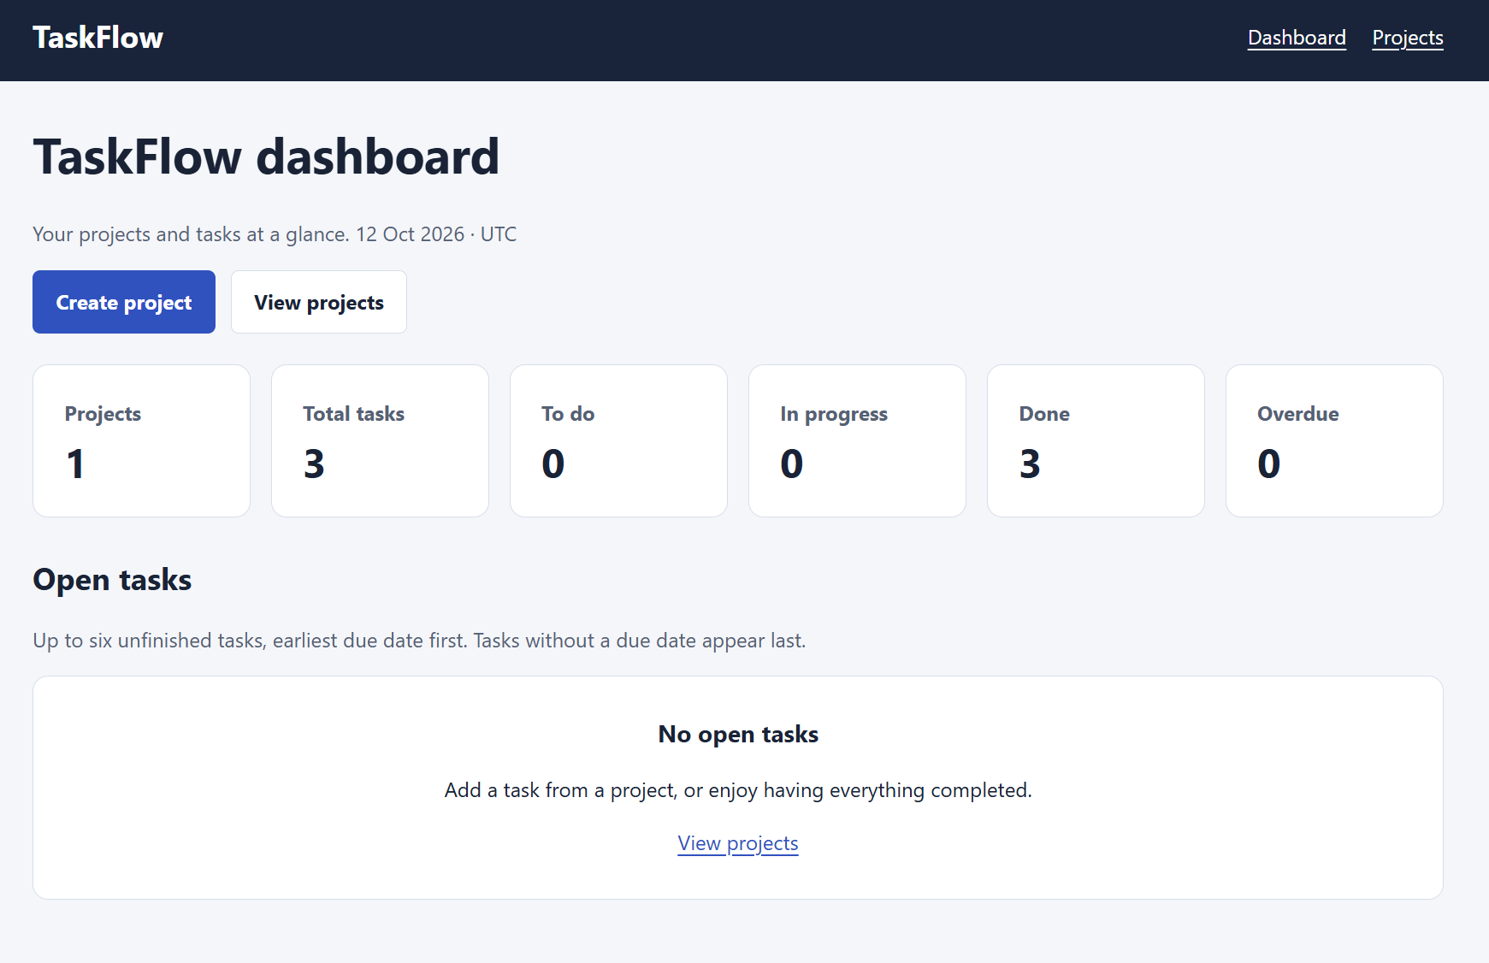
Figure 1: TaskFlow dashboard in the local development environment, showing one project, three completed tasks and no overdue tasks.

1.2 Scope and Evaluation Targets
The pipeline separates four responsibilities: source code management, building, testing and staging, and production hosting. GitHub provides the Code Repository environment, while separate Azure virtual machines host the CI/Build, Test/Staging and Production environments. Keeping these responsibilities separate means each change is evaluated before it reaches production and test activity never affects the live application. Section 2 presents the architecture and the connections between these environments.
The toolchain uses GitHub Actions on a self-hosted runner for pipeline execution, GitHub Container Registry for application images, Docker and Docker Compose as the runtime, and Prometheus and Grafana for monitoring. Each image is built once, tagged with its commit identifier, and promoted unchanged through staging to production, so the version deployed to production is exactly the version that passed testing. Environment-specific configuration is supplied through environment variables and encrypted GitHub Secrets.
The project targeted, and achieved, all four assessment levels. Level 1 established and connected the repository, build, test/staging and production environments. Level 2 added production monitoring with Prometheus, Node Exporter and Grafana, including CPU, memory, disk and HTTP latency measurements and tested alert rules. Level 3 built, tested and deployed the application through the pipeline: unit and integration tests with an 80% coverage gate, followed by end-to-end browser tests against the deployed release on the staging server. Level 4 automated the complete sequence, so a merge to main reaches production with no manual steps, a failing test stops the release before production, and a failed production health check triggers an automatic rollback.
We evaluated the project against the quantitative success metrics defined in the Project Brief, using workflow run history, test and coverage reports, deployment logs and production monitoring data. Section 3 provides captioned screenshots and formatted logs for each level, Section 4 records the problems encountered and how they were resolved, and Section 5 compares the measured results with the original targets and reflects on the outcomes.

2. Pipeline Design & Toolchain Evolution

2.1 Architecture and Deployment Strategy
The AeroDeploy pipeline separates four environments: Code Repository, CI/Build, Test/Staging and Production. GitHub hosts the Code Repository, while the other three environments run on separate Azure Ubuntu 24.04 virtual machines (Standard_B2s_v2, Australia East) in the resource group aerodeploy-rg. Figure 2 shows the final architecture and the connections between these environments.
Developers work on feature branches and open pull requests against main. Branch protection requires a passing “check” status and one approving review from the code owner before a merge is allowed. Each merge to main triggers the GitHub Actions workflow on a self-hosted runner installed on the CI/Build VM (ci-build-vm, 4.197.146.206). The runner first executes the unit and integration test suite with coverage in an isolated Docker Compose environment, then builds the application image once and pushes it to GitHub Container Registry (GHCR) tagged with the full commit SHA.
The same SHA-tagged image is then promoted through the remaining environments without being rebuilt. The runner connects over SSH, using a dedicated deploy account, to the Test/Staging VM (aerodeploy-staging, 20.211.123.224), which pulls the image, starts it with its own PostgreSQL database and runs eight Playwright end-to-end browser tests against the deployed release. Only if every test passes does the workflow deploy the identical image to the Production VM (aerodeploy-prod, 20.70.170.224). There, Nginx accepts public traffic on port 80 and forwards it to Gunicorn on 127.0.0.1:8000, which cannot be reached from the internet.
Every deployment first backs up the database, then checks the /health endpoint, which verifies both the application and its database connection, for up to 60 seconds. If the check fails, the previous image and its configuration are restored automatically. A final step requests /health through Nginx from outside the server, so a release is only marked successful if real users can reach it. Prometheus, Node Exporter and Grafana run alongside the application on the Production VM and collect host and application metrics.
Network access follows the principle of least privilege. Staging and Production accept SSH only from the CI/Build VM and the team’s IP address, Production exposes only port 80 publicly, Grafana is restricted to the team’s IP address, and Prometheus is bound to localhost. Secrets such as SSH keys and database passwords are stored as encrypted GitHub Secrets and written to a .env file on each server at deployment time, so they never appear in the repository.
Figure 2 shows that a change can be stopped at three points before it affects users. The first is the CI/Build stage, where any failing unit or integration test, or coverage below 80%, fails the required check and prevents the change from being merged or built. The second is the Test/Staging stage, where a failing browser test skips the production deployment entirely, so the live site keeps running the last approved version. The third is Production itself, where a failed health check after deployment triggers an automatic rollback to the previous image and settings. Because the same image moves through every stage, each of these checks applies to the exact release that users will receive, rather than to a separate build of the same code.

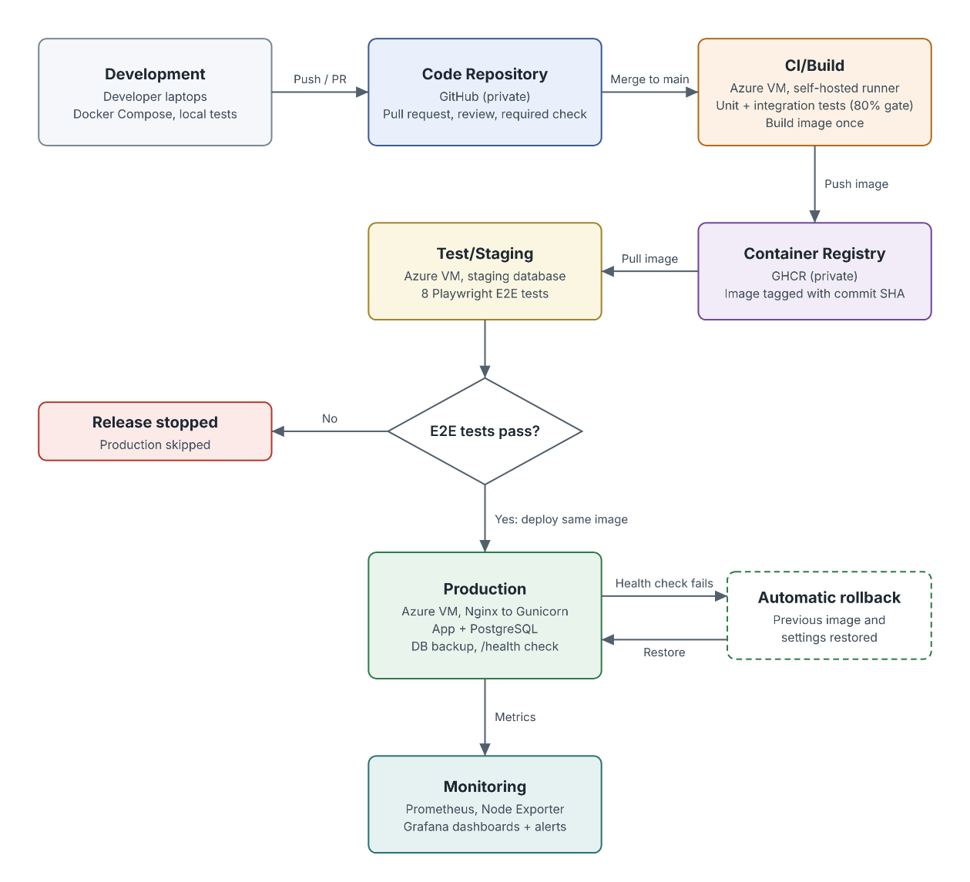
Figure 2: Planned AeroDeploy pipeline architecture showing the repository, build, test/staging and production environments, with container storage and monitoring.

2.2 Toolchain, Configuration and Alignment with the Brief
We retained the Flask, Jinja and PostgreSQL application architecture described in the Project Brief, and the selected tools were unchanged: GitHub, GitHub Actions, GitHub Container Registry, Docker, Azure virtual machines, pytest, Playwright, Prometheus and Grafana. However, both the application and the pipeline evolved during implementation. Table 1 summarises the application-side changes, and Table 2 records the pipeline and infrastructure changes, each with its technical justification.
Table 1: Application-side changes and configuration alignment.
Area | Change or alignment | Reason
Runtime and dependencies | We aligned the container with Python 3.12 and updated the early Gunicorn 23 configuration to the agreed 26 series. Installed dependencies were locked. | This established a consistent application runtime for later builds.
Monitoring interface | We added Flask request instrumentation alongside the custom request counter at /metrics. | This provides request counts and duration measurements for monitoring integration.
Application interface | The root page became the dashboard, with version information retained in /api/info and the footer. Project deletion and Dashboard/Projects navigation were added. | These changes improved usability while preserving version identification.
Database setup | We added Project and Task models, versioned migrations and migration execution at startup. | This supports persistent data and repeatable setup in a fresh environment.
Automated tests | We retained the unittest-based tests and added pytest execution, coverage reporting and an isolated PostgreSQL test environment. | This provides measurable test results without affecting normal application data.
Local tooling | The recorded development environment used Docker Compose v5.5.1 rather than the Compose v2 specified in the brief. | This was a local tooling difference only. The server versions are recorded in Table 2.

The shared application agreements were kept throughout: port 8000, non-root execution, environment-based configuration, health and metrics endpoints, and migrations at startup. These agreements allowed the application, pipeline, staging and production work to be developed in parallel and integrated without changes to the application contract.
In addition to the application-side changes, the pipeline and infrastructure evolved during implementation. Table 2 records each deviation from the Project Brief and the technical reason for it.
Table 2: Pipeline and infrastructure changes since the Project Brief.
Area | Brief | Final Implementation | Justification
Location of unit and integration tests | Run on the Test/Staging VM against the staging database | Run on the CI/Build VM in the “check” job, in an isolated Docker Compose stack with its own PostgreSQL container, before the image is built | Failing changes are rejected within about 30 seconds, before any build or deployment, and the same job is the required pull request check. The test database is created and destroyed each run, so it is isolated as the brief intended. Test/Staging is used to test the deployed release with Playwright, as the brief also required.
Azure subscription | Team Azure subscription | Azure for Students subscription shared through Contributor roles | The original free trial expired and the university subscription was restricted.
VM size | Not fixed | Standard_B2s_v2 for all three VMs | Recommended sizes were unavailable to the student subscription in Australia East. Three B2s_v2 VMs fit exactly within the 6 vCPU quota.
Pipeline delivery | One workflow | Built in three iterations: v1 (test, build, push), v2 (production deployment, backup, health check, rollback) and v3 (staging job, shared deploy script, improved rollback), followed by the staging E2E gate, the strict public Nginx check and Node 24 action versions | Incremental delivery let each stage be verified before the next depended on it.
Rollback | Redeploy the previous image | Restore both the previous image tag and its configuration from .env.prev | The first version restored the image but kept the new settings, which could leave an old image running with incompatible configuration.
Post-deploy check | /health on the server | /health on the server, plus a second check through Nginx from the runner | This verifies the path users take, and it caught a production issue described in Section 4.6.
Failure demonstrations | A deliberately failing commit | Manual workflow inputs simulate_failure (wrong production database password) and simulate_e2e_failure | Failure handling can be demonstrated repeatably without committing broken code to main.
Deployment account | Not specified | A dedicated deploy user in the docker group on Staging and Production, with its own key pair | The pipeline does not use personal administrator accounts, and its access can be revoked separately.
E2E heading assertion | Exact text match | Checks that the heading contains the title | An exact match failed on a legitimate content change (Section 4.6).
Alert rules | Grafana alert rules | Prometheus alert rules, displayed in Grafana | Rules are kept in version-controlled configuration and evaluated by Prometheus directly.
Docker Compose version | Compose v2 | Compose v2.40 on Staging and v5.6 on Production | These were the plugin versions available from Docker’s repository at install time. The Compose file format is unchanged.

None of these changes altered the project’s goals or its four-environment design. Most of them increased safety, such as the stricter rollback, the public health check and the dedicated deployment account, or resulted from constraints of the student Azure subscription. The most significant deviation, running unit and integration tests on the CI/Build server, kept the same isolation the brief required while giving faster feedback, and the Test/Staging environment still verifies every release before it reaches production.

3 - Level-by-Level Implementation & Evidence

3.1 Level 1: Pipeline Infrastructure
Overview
Level 1 required four separate environments to be created and connected: the Code Repository, CI/Build, Test/Staging and Production. Table 3 summarises the final environments, and Table 4 lists every connection between them. The remainder of this section provides the setup and connection evidence for each environment.
Table 3: Pipeline environments.

Table 4: Connections between environments.

Local Development Preparation
We created the workspace under AeroDeploy\TaskFlow and checked the development tools before building the application. The checks confirmed Git 2.53.0.windows.1, Python 3.13.7, Docker 29.7.2 with build a7dcaa6, and Docker Compose v5.5.1. Docker also reported server version 29.7.2 and confirmed that Docker Desktop was running Linux containers. This established that the local Docker engine was accessible. The Python version reported here belongs to the laptop; the application uses Python 3.12 inside its container.
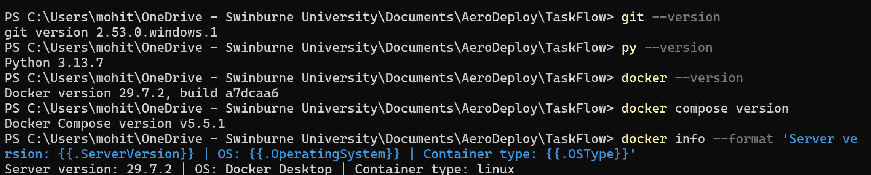
Figure 3: Local development tool checks and Docker Desktop Linux-engine verification.
We organised the workspace according to the team’s agreed layout. The app directory holds the Flask application, docs contains setup instructions, and deploy was reserved for server deployment configuration. Separate directories were prepared for unit, integration and end-to-end tests. We also renamed compose.yaml to docker-compose.yml to follow the team’s naming agreement.
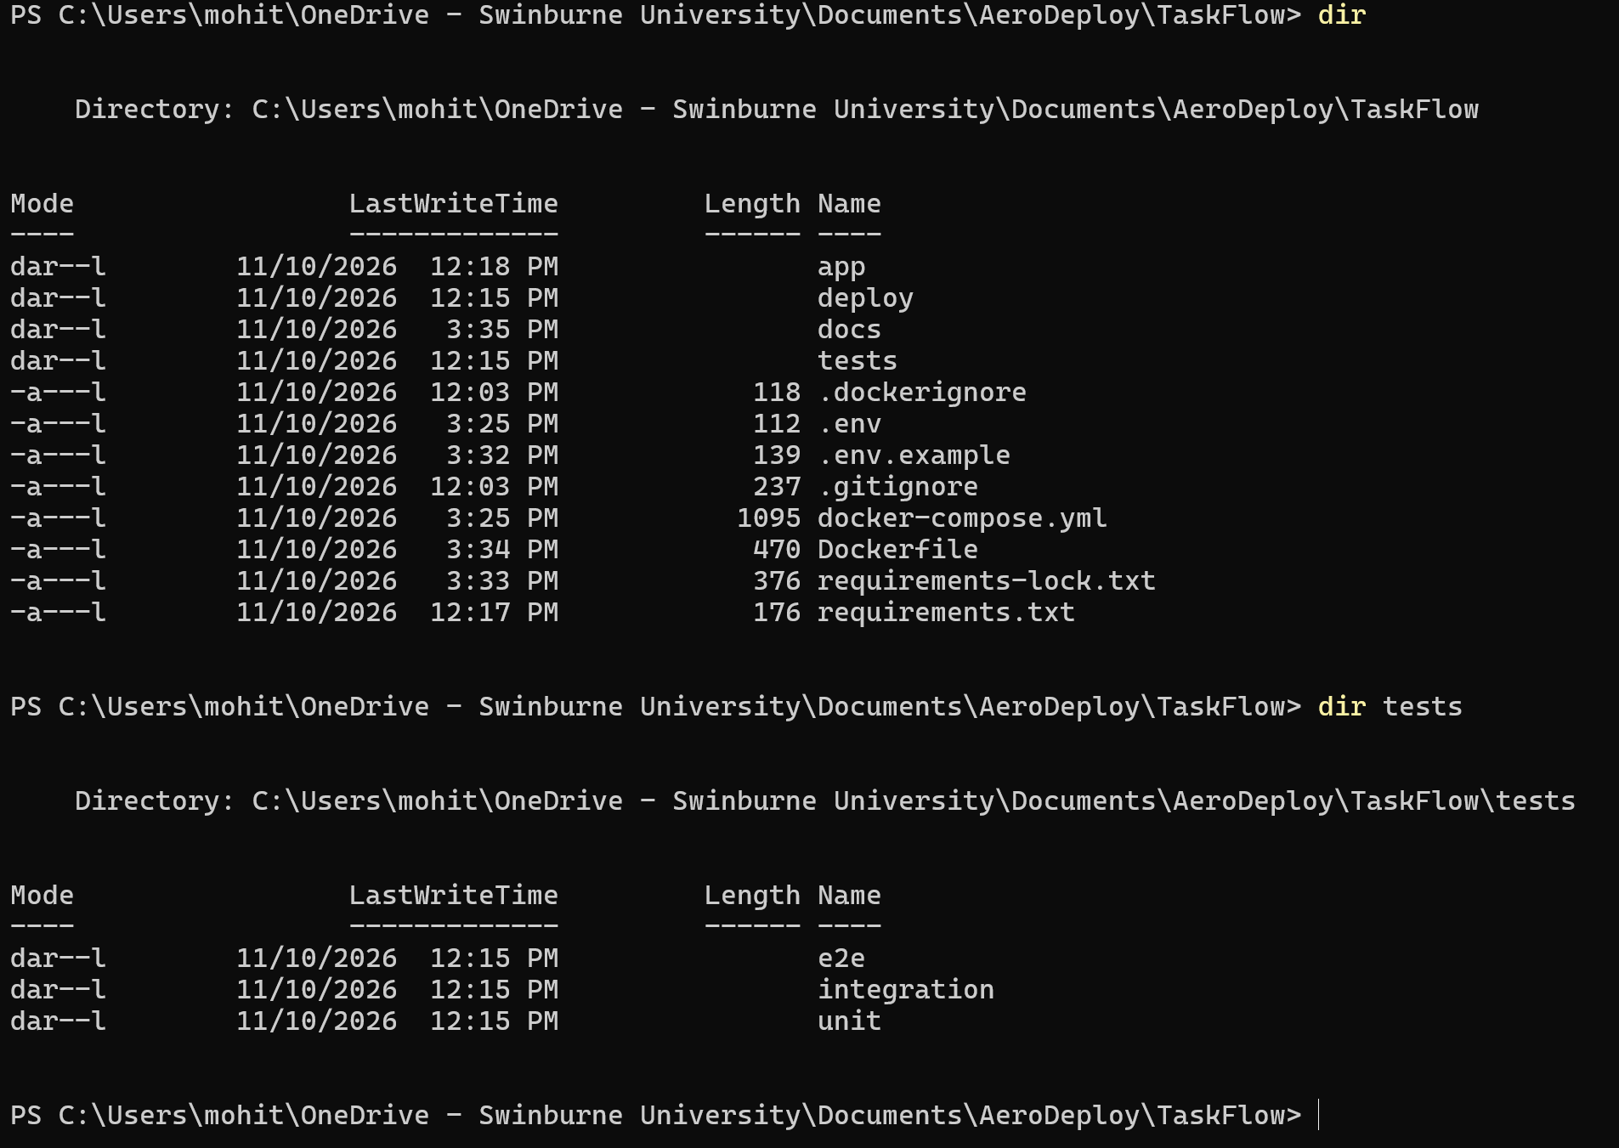
Figure 4: Initial TaskFlow workspace structure, including directories prepared for application code, documentation, deployment and automated tests.
At this stage, the deployment and test directories were placeholders. The unit and integration tests were implemented later, as documented in Section 3.3.
Code Repository and Application Handover
We cloned the shared repository at https://github.com/AdityA-exe-99/taskflow and created the branch feature/taskflow-application. We added the application, container configuration, database migrations, tests and handover documentation while preserving the existing team repository structure.
After correcting trailing whitespace in the migration file, the staged whitespace check returned no remaining errors. We created commit b84b39d, titled “Add TaskFlow application, containers and automated tests”, and pushed the branch successfully. The commit contained 36 changed files.
We opened pull request #1 against main for team review. The contribution was reviewed and merged, bringing the application, container configuration, migrations, tests and handover documentation into the main branch. This confirms repository integration; testing on Test/Staging and production deployment require separate evidence.
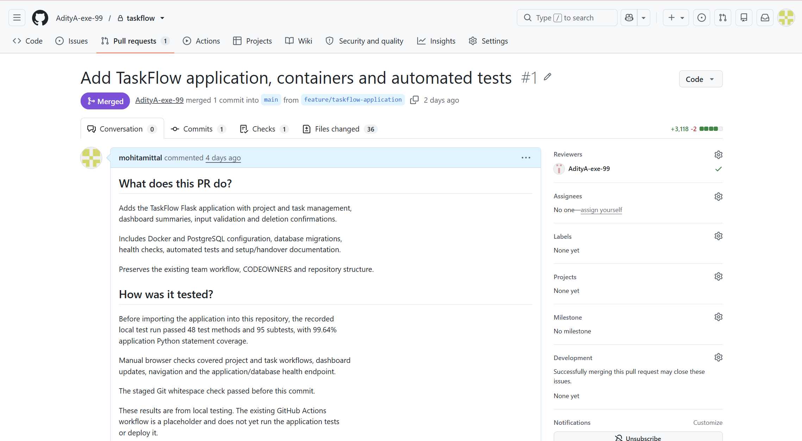
Figure 5: TaskFlow application contribution reviewed and merged into the main branch through pull request #1, containing one commit and 36 changed files.

CI/Build Server Setup and Runner Registration
Test/Staging Server Setup
We created a separate Azure virtual machine for the Test/Staging environment so that every release could be deployed and tested in a production-like setting before reaching users. The VM, named aerodeploy-staging, runs Ubuntu 24.04 on a Standard_B2s_v2 size in the Australia East region, in the shared aerodeploy-rg resource group, with the public IP address 20.211.123.224. We used the same operating system and VM size as the Production VM so that test results would reflect the production environment as closely as possible.
We generated an Ed25519 SSH key pair on a team member's computer and supplied the public key when creating the VM, so that administrator login uses a key rather than a password. Successful login was confirmed by the terminal prompt azureuser@aerodeploy-staging.
After updating the system packages and restarting the VM to apply a pending kernel update, we installed Docker and the Docker Compose plugin (version 2.40.3) and ran the hello-world container to confirm that the container runtime worked. We then created the deployment directory /opt/aerodeploy, where the pipeline places the Compose file and environment settings for each release.
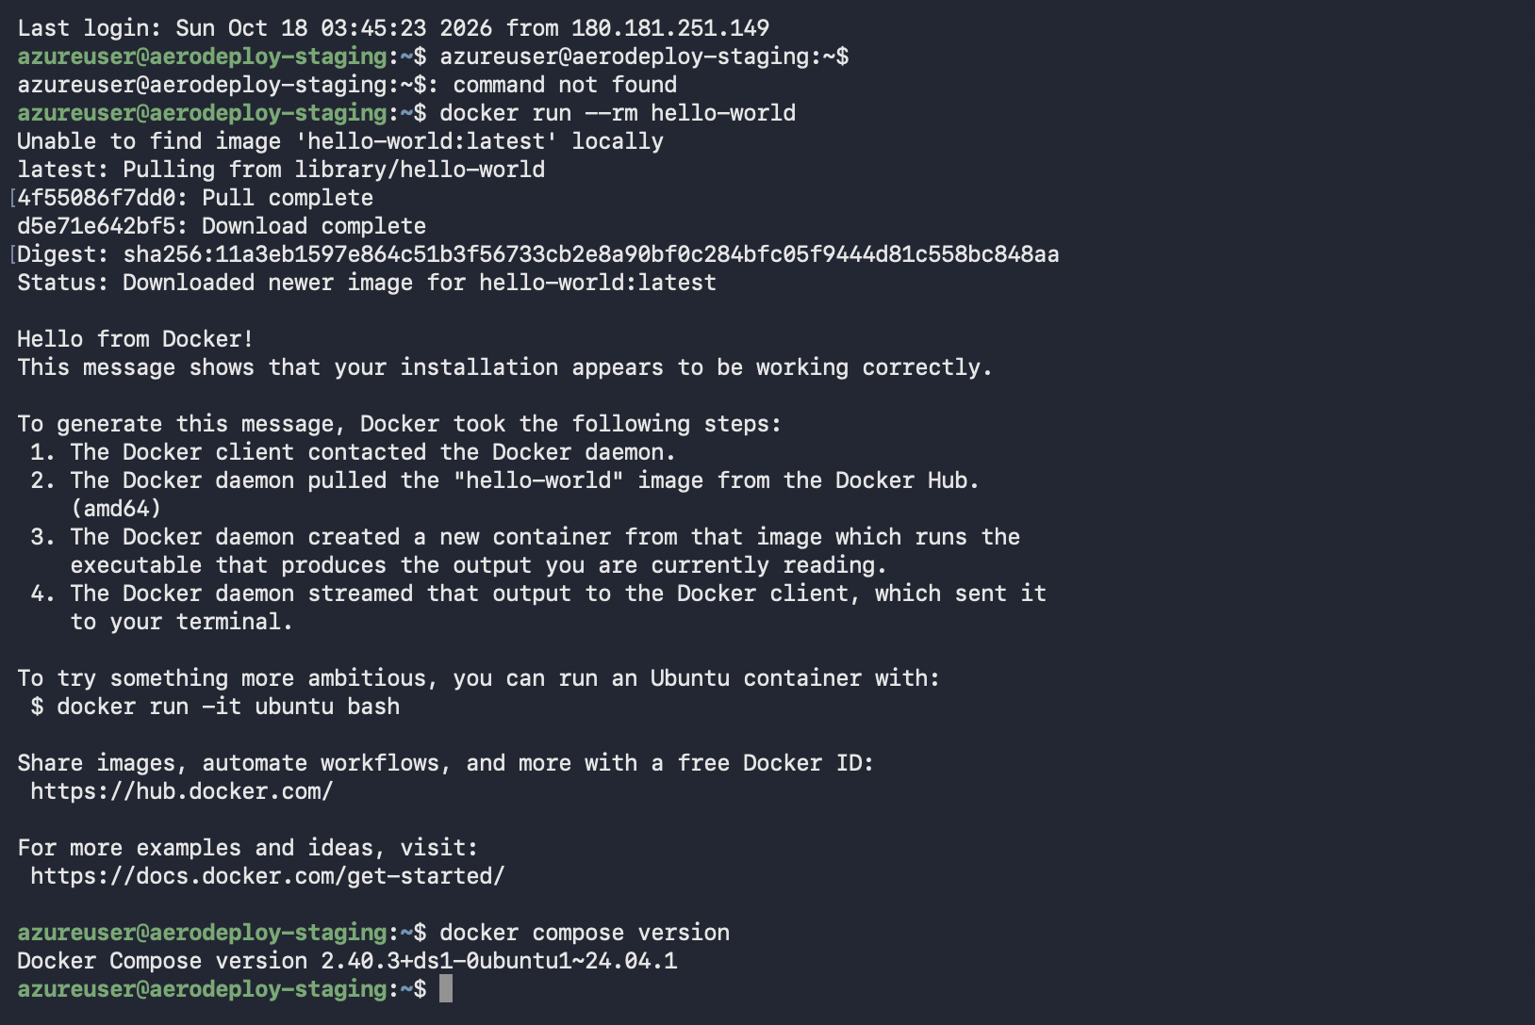
Figure X: A successful hello-world container (amd64) and Docker Compose 2.40.3 on the staging VM.
We added a dedicated deploy user through the VM's Reset password page in Azure, using the Add SSH public key mode with the pipeline's public key (aerodeploy-pipeline). We then added the user to the docker group and gave it ownership of /opt/aerodeploy. The pipeline therefore connects to staging through its own account rather than a team member's, and this access can be removed separately if needed.
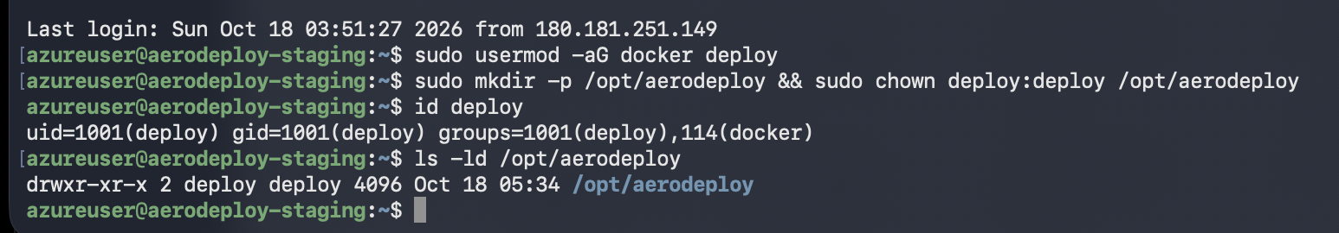
Figure X: The deploy user added to the docker group, and /opt/aerodeploy owned by the deploy user.
We restricted inbound access with the VM's network security group. SSH on port 22 is allowed only from the CI/Build server (4.197.146.206), through the Allow-SSH-CI rule used by the pipeline, and from the team's IP address for administration. No HTTP rule was added: the application binds only to 127.0.0.1:8000 on the VM, so the staging site and its database cannot be reached from the internet. This keeps unfinished releases and test data private while still allowing the pipeline to reach the server.
Finally, we pre-pulled the official Playwright image (mcr.microsoft.com/playwright/python:v1.63.0-noble), which contains Python and the browsers needed for end-to-end testing. Keeping the browsers inside a pinned container image means nothing extra needs to be installed on the VM, and every test run uses the same versions.
Production Server Setup
We created a separate Azure virtual machine for the Production environment so that live traffic would be kept apart from building and testing. The VM, named aerodeploy-prod, runs Ubuntu 24.04 on a Standard_B2s_v2 size in the Australia East region, with the public IP address 20.70.170.224.
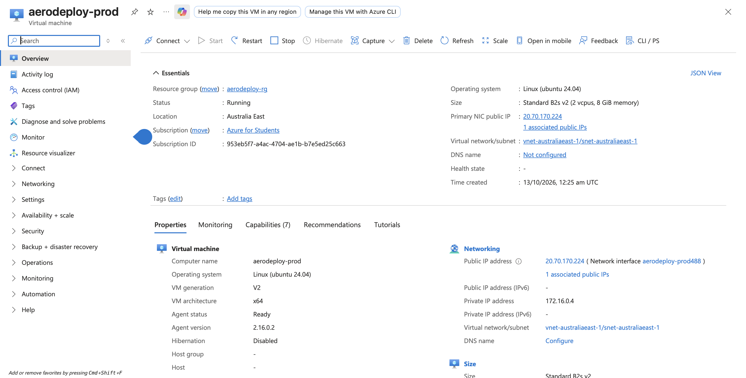
Figure x Azure overview of the aerodeploy-prod production VM, showing its size, region and public IP address.
We generated a dedicated SSH key pair (aerodeploy_prod) on a team member’s computer and used it to log in to the VM instead of a password. Successful login was confirmed by the terminal prompt azureuser@aerodeploy-prod.
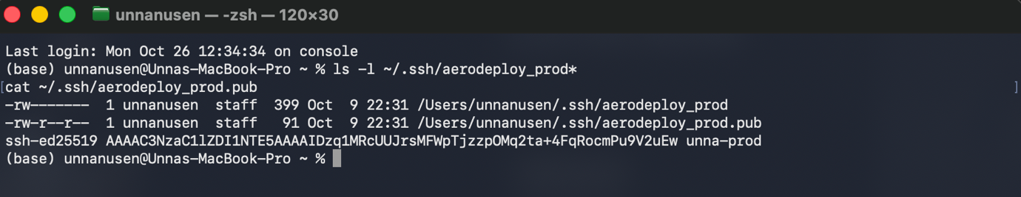Figure X: Generation of the aerodeploy_prod SSH key pair.
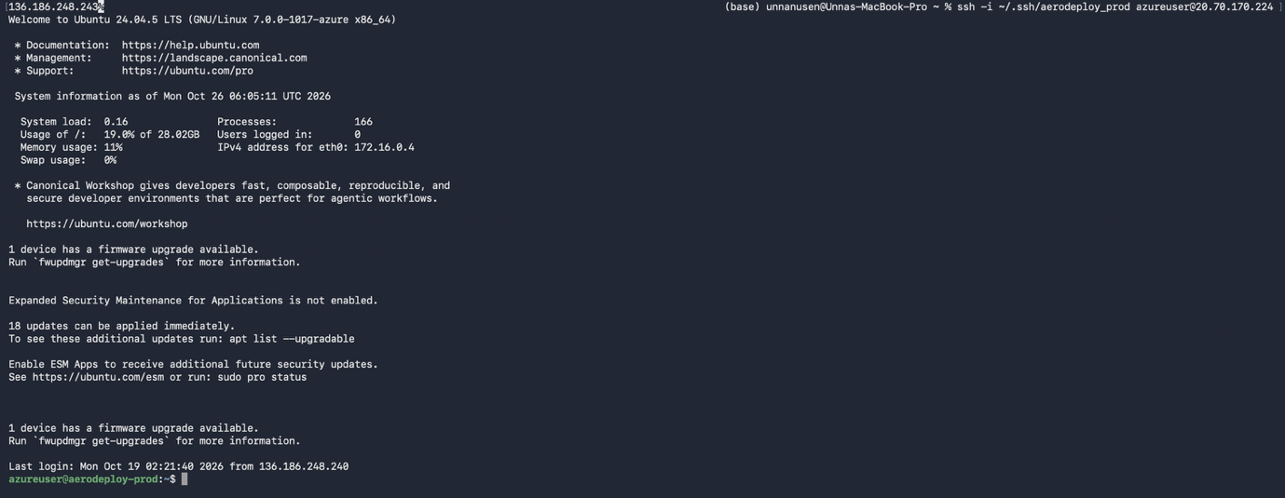Figure X: SSH login to the production VM using the key.
We then installed Docker and Docker Compose and ran the hello-world container to confirm that the container runtime worked.
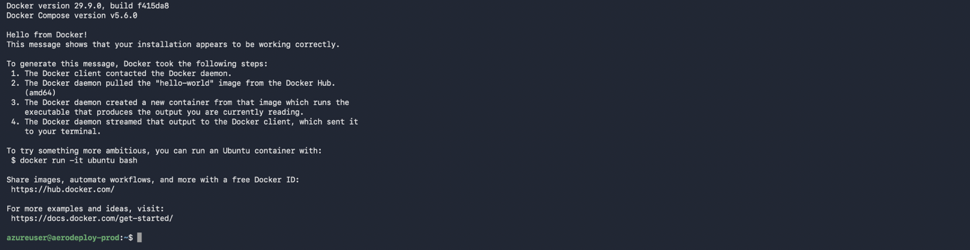Figure X: Docker and Docker Compose versions and a successful hello-world container on the production VM.
We also installed Nginx and served a temporary placeholder page on port 80, which confirmed that the server could be reached from a browser before the application was deployed.
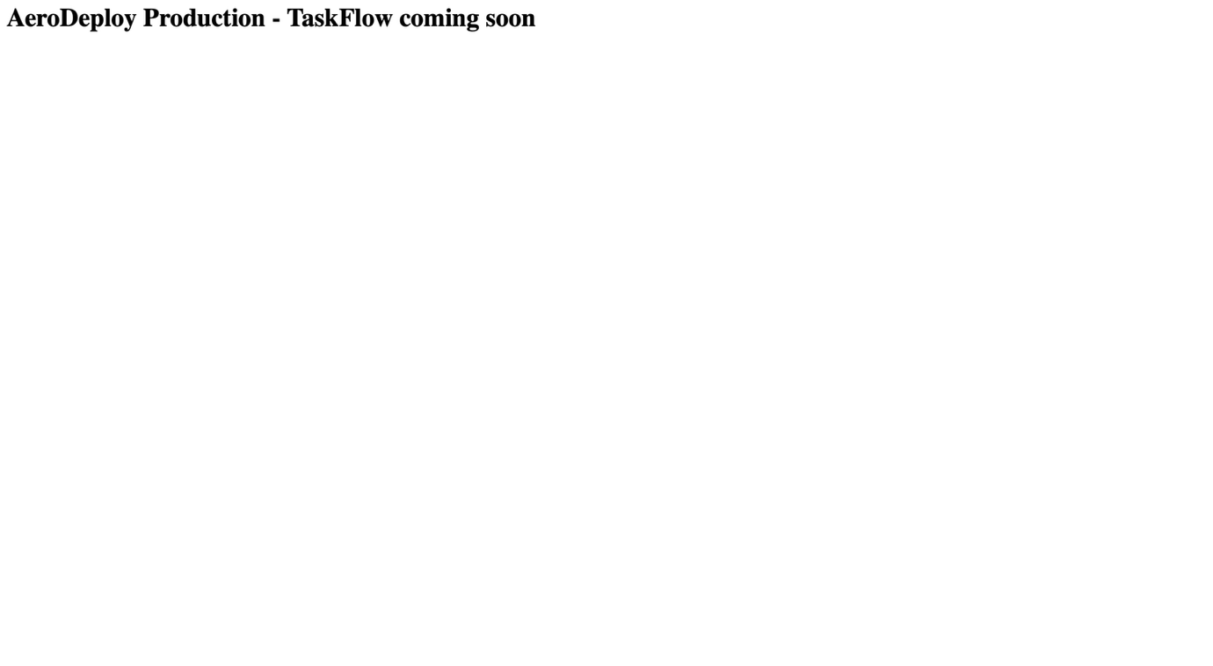Figure X: Nginx placeholder page served at http://20.70.170.224.
Environment Connections and Access Controls
We restricted inbound access to the production VM using its Azure network security group (NSG), which acts as a firewall in front of the server. HTTP on port 80 is open to all users because it serves the application. SSH (port 22) and Grafana (port 3000) are allowed only from the team’s IP address, and a separate rule allows SSH from the CI/Build server (4.197.146.206) so that the pipeline can deploy. Prometheus (port 9090) and Node Exporter have no inbound rules, so they cannot be reached from the internet. Any traffic not matching these rules is blocked by the default DenyAllInBound rule. Opening only the ports each role needs limits the server’s exposure to unwanted access.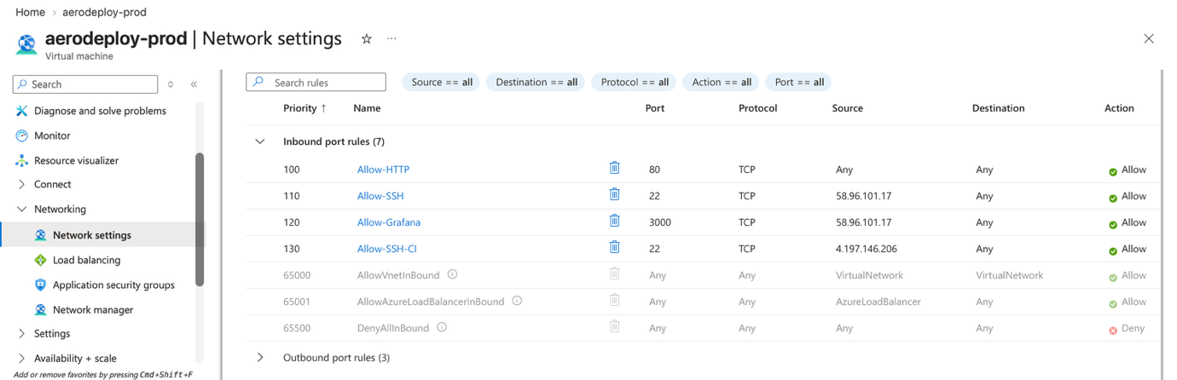
Figure x(a): Inbound security rules for the production VM, allowing HTTP from any source, SSH and Grafana from the team’s IP address, and SSH from the CI/Build server.
For automated deployment, we created a dedicated deploy user on the production VM and added it to the docker group so that it can manage containers without full administrator rights. We then added the pipeline’s public key (aerodeploy-pipeline) to this user’s authorised keys. As a result, the pipeline connects through its own limited account rather than a team member’s account, and its access can be removed separately if needed.
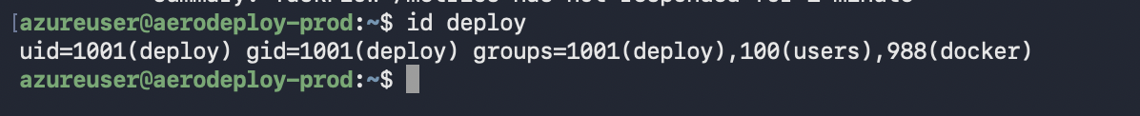Figure x(b): The deploy user and its docker group membership.
Figure x(c): The aerodeploy-pipeline public key added to the deploy user’s authorised keys.

3.2 Level 2: Instrumentation & Monitoring
Local Application Instrumentation
We provided a /metrics endpoint containing application request measurements. Local checks showed request-duration measurements and a custom request counter grouped by endpoint, request method and response status. This demonstrated that the application could expose measurements for Prometheus collection.
The recorded counters include automated health-check requests, so their totals should not be interpreted as user traffic. These checks establish local instrumentation; production monitoring requires separate evidence from the deployed environment.
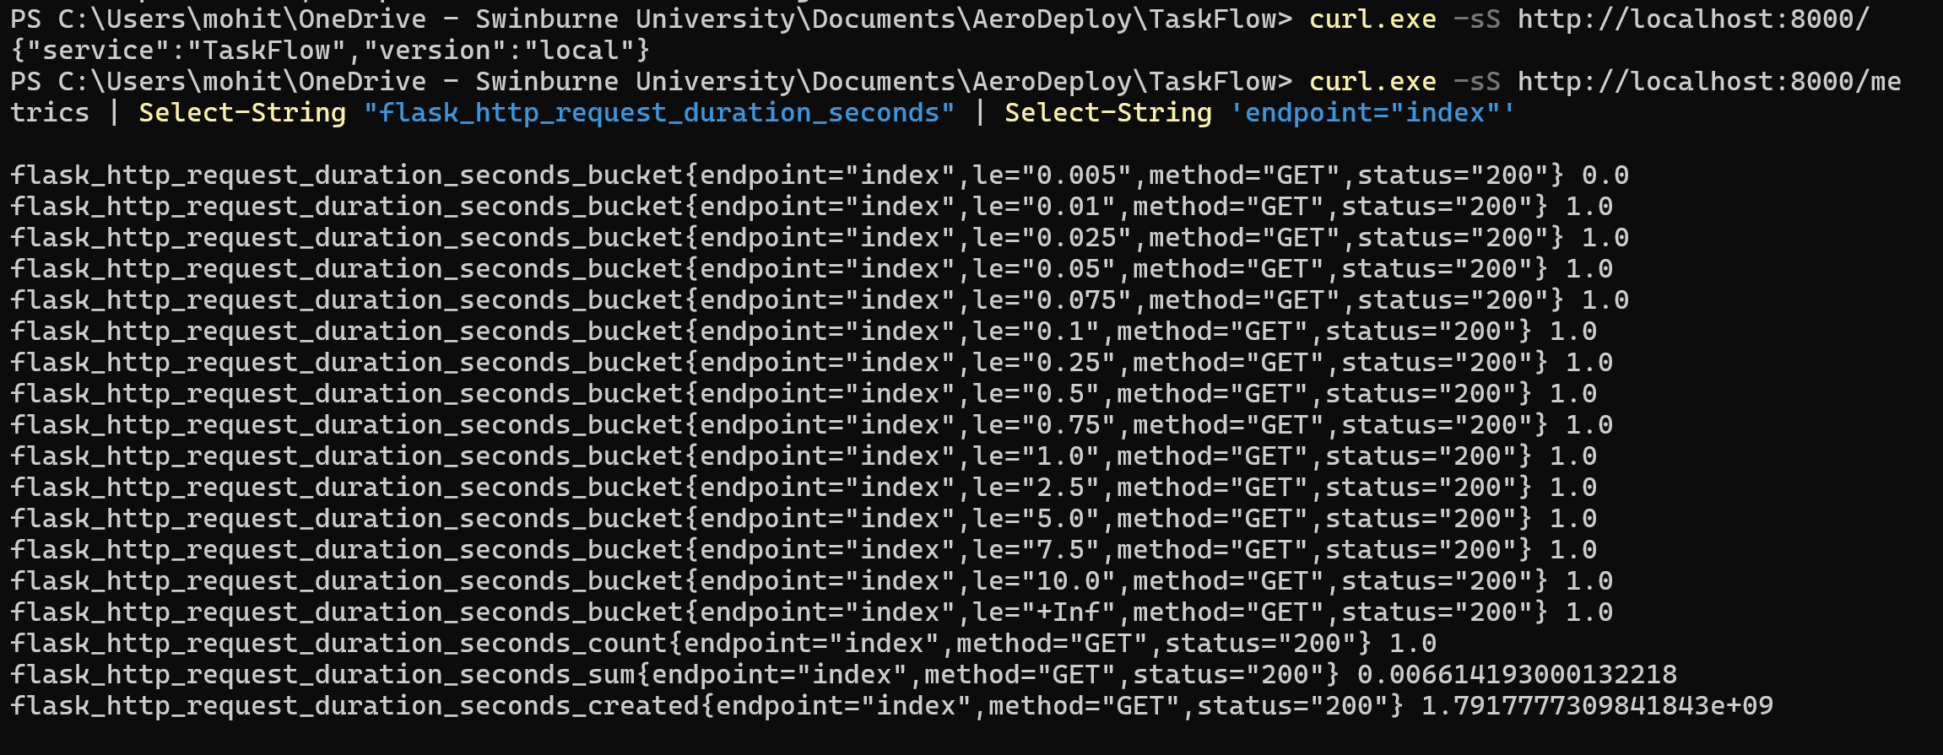
Figure x(a). Request-duration histogram for the TaskFlow root endpoint.
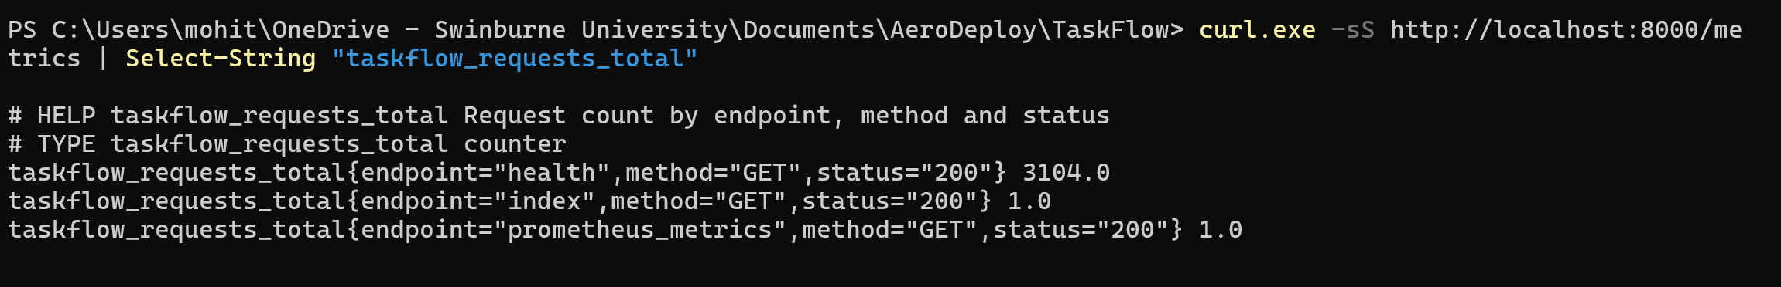
Figure x(b). TaskFlow request counts by endpoint, HTTP method and response status.
Production Monitoring Configuration
We deployed the production monitoring stack on the production VM using Docker Compose, from a separate ~/monitoring directory so that it is managed independently of the application. The stack contains three services: Prometheus, which collects and stores measurements; Node Exporter, which reports host-level metrics such as CPU, memory and disk usage; and Grafana, which displays the collected data as dashboards.
Figure x(a): Prometheus, Node Exporter and Grafana containers running on the production VM.
Prometheus is configured to collect measurements every 15 seconds from three targets: itself, Node Exporter, and the TaskFlow application’s /metrics endpoint at web:8000. Because the application runs in a separate Docker Compose project, Prometheus could not initially reach it. We therefore connected Prometheus to the application’s Docker network (aerodeploy-taskflow_default), which allows it to reach the web container by name. Grafana uses Prometheus as its data source. After the first production deployment, both the node and taskflow targets reported a status of UP, confirming that host and application metrics were being collected.
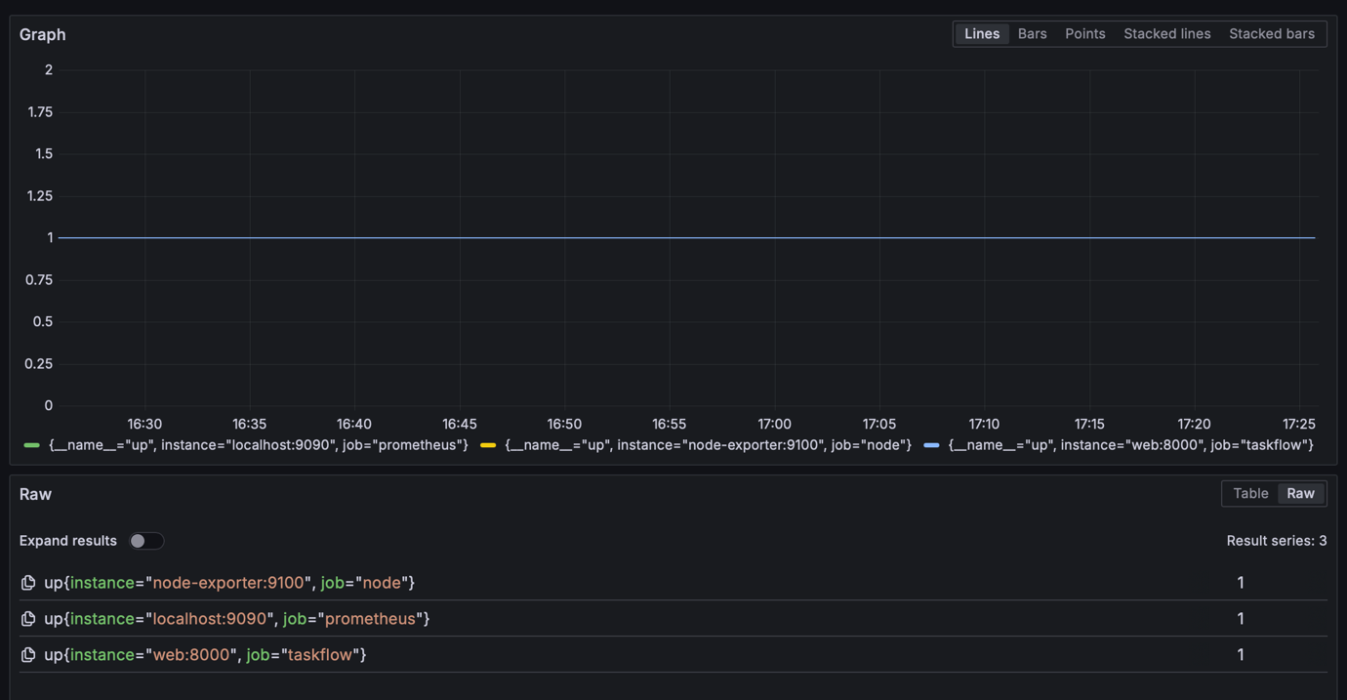Figure x(b): Prometheus targets queried in Grafana, showing the node, prometheus and taskflow jobs all reporting as up (value 1).
Production Dashboards and Performance Metrics
We imported the community Node Exporter Full dashboard into Grafana to visualise the production server’s resource usage in real time, including CPU utilisation, memory usage, disk space and network traffic.

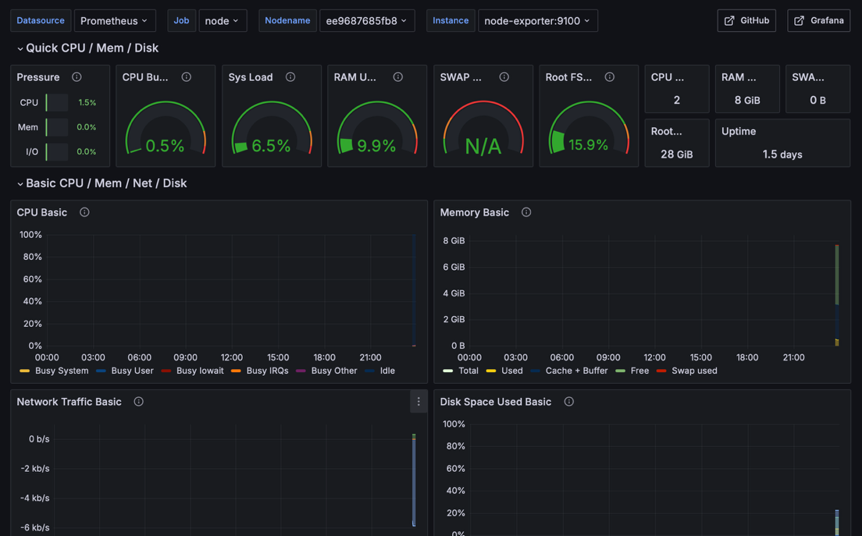
Figure x(a): Node Exporter Full dashboard showing live CPU, memory, disk and network metrics for the production VM.
To monitor the application itself, we added three panels based on the TaskFlow request metrics. The App up panel shows 1 when Prometheus can reach the application and 0 when it cannot. The Error rate panel shows the percentage of requests that returned a server error (HTTP 5xx). The Response time (p95) panel shows the 95th-percentile request duration, meaning the time within which 95% of requests were completed; this is more useful than an average because it reflects the slower requests that users notice. On 20 October, the panels showed the application as up, an error rate of 0% and a p95 response time of 0.00492 seconds (about 5 milliseconds). These results show that the application was available and responding quickly under the light traffic at the time, but they do not measure its behaviour under heavy load.
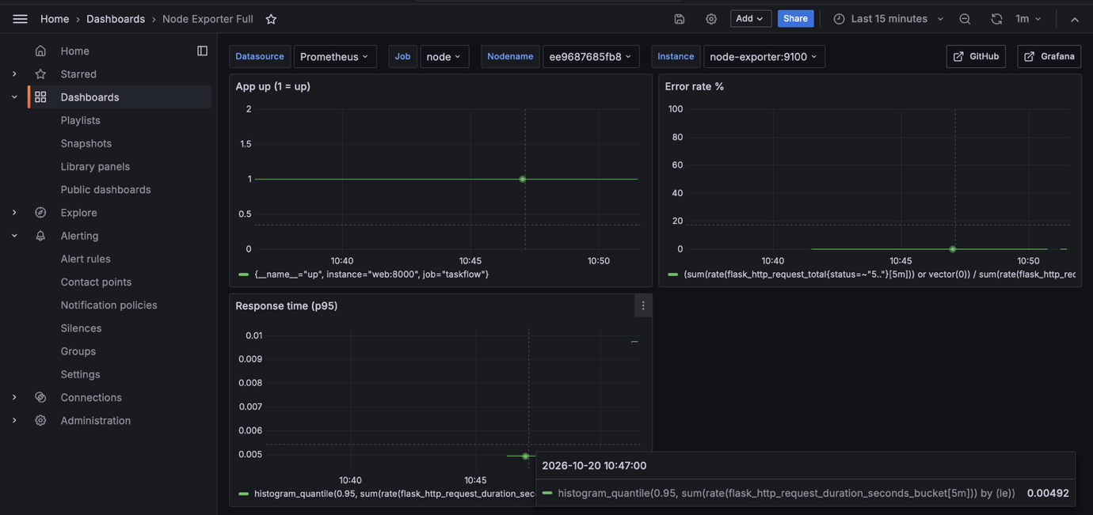Figure x(b): Grafana application panels showing availability, error rate and a p95 response time of 0.00492 seconds.
Alert Configuration and Verification
We defined alert rules in Prometheus to detect problems on the production server and in the application. Three host rules were configured first: HighCPU fires when CPU usage stays above 80% for five minutes, HighMemory fires when memory usage stays above 80% for five minutes, and DiskAlmostFull fires when the root disk is more than 85% full for one minute. After the application was deployed, we added a fourth rule, TaskFlowDown, which fires when Prometheus cannot reach the application’s /metrics endpoint for one minute. The “for” duration prevents short, harmless spikes from triggering an alert. The rules are loaded by Prometheus and displayed in Grafana.
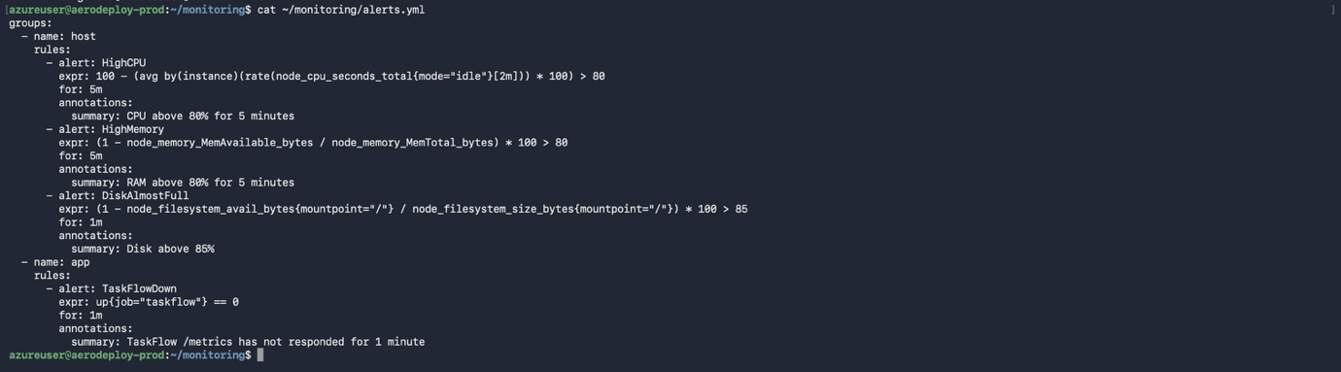Figure x(a): Prometheus alert rules file defining the HighCPU, HighMemory, DiskAlmostFull and TaskFlowDown alerts.
On 16 October, we tested the HighCPU rule by running a CPU stress container on the production VM to push CPU usage close to 100%. Shortly after CPU usage passed 80%, the alert moved from Normal to Pending, meaning the condition had been met but had not yet lasted for five minutes. Once the high usage had continued for five minutes, the alert changed to Firing. After the stress container was stopped, CPU usage returned to normal and the alert returned to the Normal state. This confirmed that the rule detected a sustained CPU spike and cleared itself afterwards.
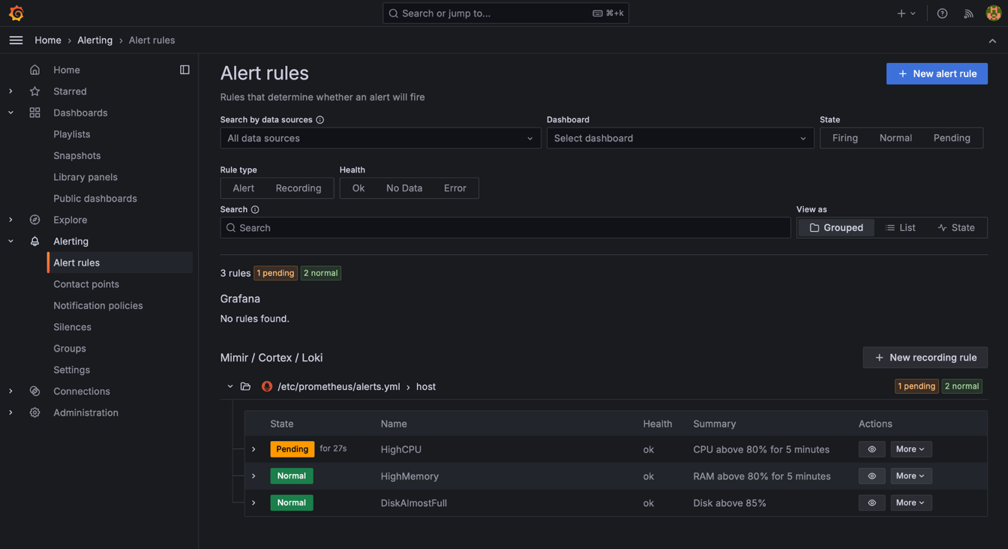Figure x(b): HighCPU alert in the Pending state shortly after the stress test began.
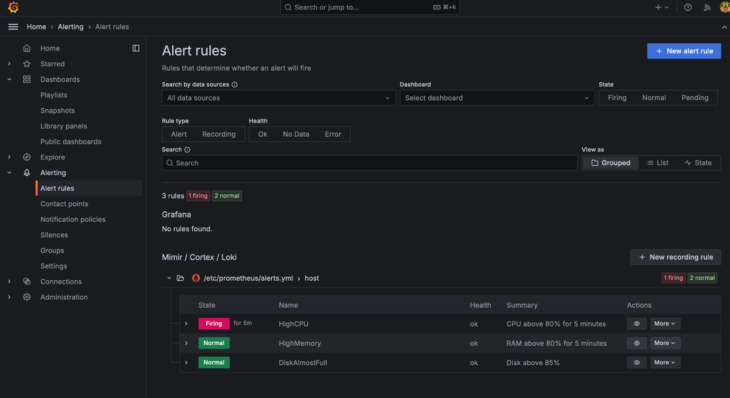Figure x(c): HighCPU alert in the Firing state after five minutes of high CPU usage.
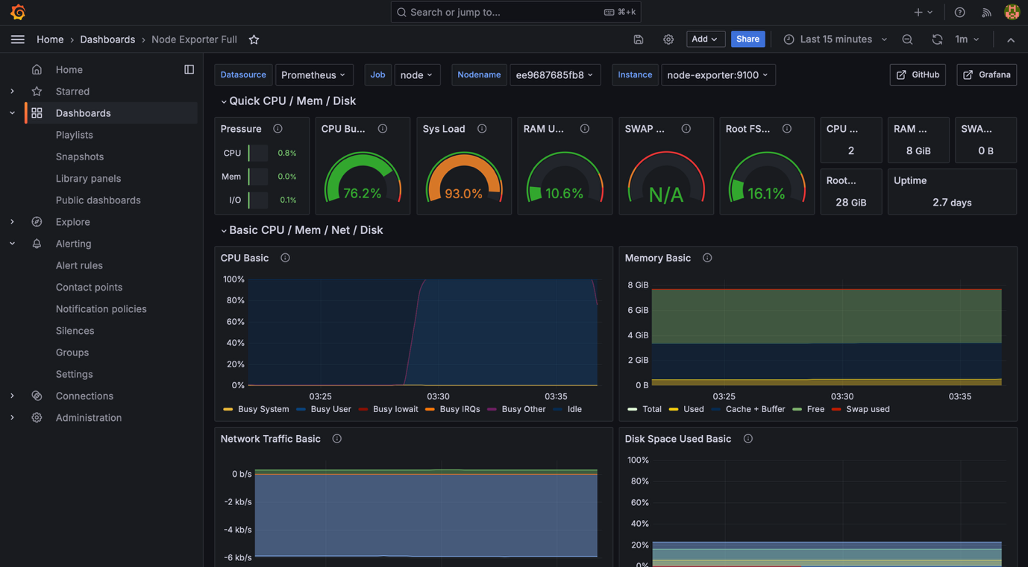Figure x(d): Grafana CPU chart showing the spike during the stress test.
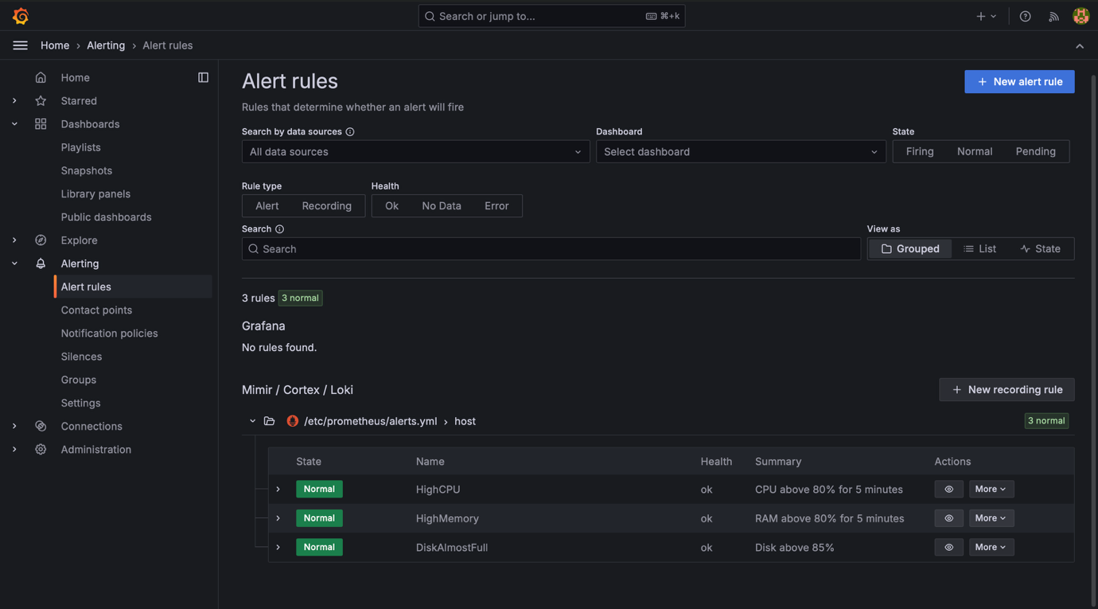Figure x(e): HighCPU alert back in the Normal state after the test ended.
Alerts are currently shown only in the Prometheus and Grafana interfaces. No email or chat notification is configured, so a team member must check the dashboards to notice an alert. This limitation is discussed in Section 5.6.

3.3 Level 3: Application Deployment & Verification
Local Application and Container Setup
We separated the application’s main responsibilities into route handling in views.py, database models in models.py and input validation in validation.py. Jinja templates display the pages, while the shared stylesheet controls their layout.
The application and PostgreSQL run as separate Docker services. Container checks confirmed Python 3.12.15 and execution under the non-root taskflow account, with user identifier 999. We installed dependencies from a lock file and supplied configuration through environment variables. Source compilation checks and the recorded container build completed successfully, with both application and database services reporting healthy.
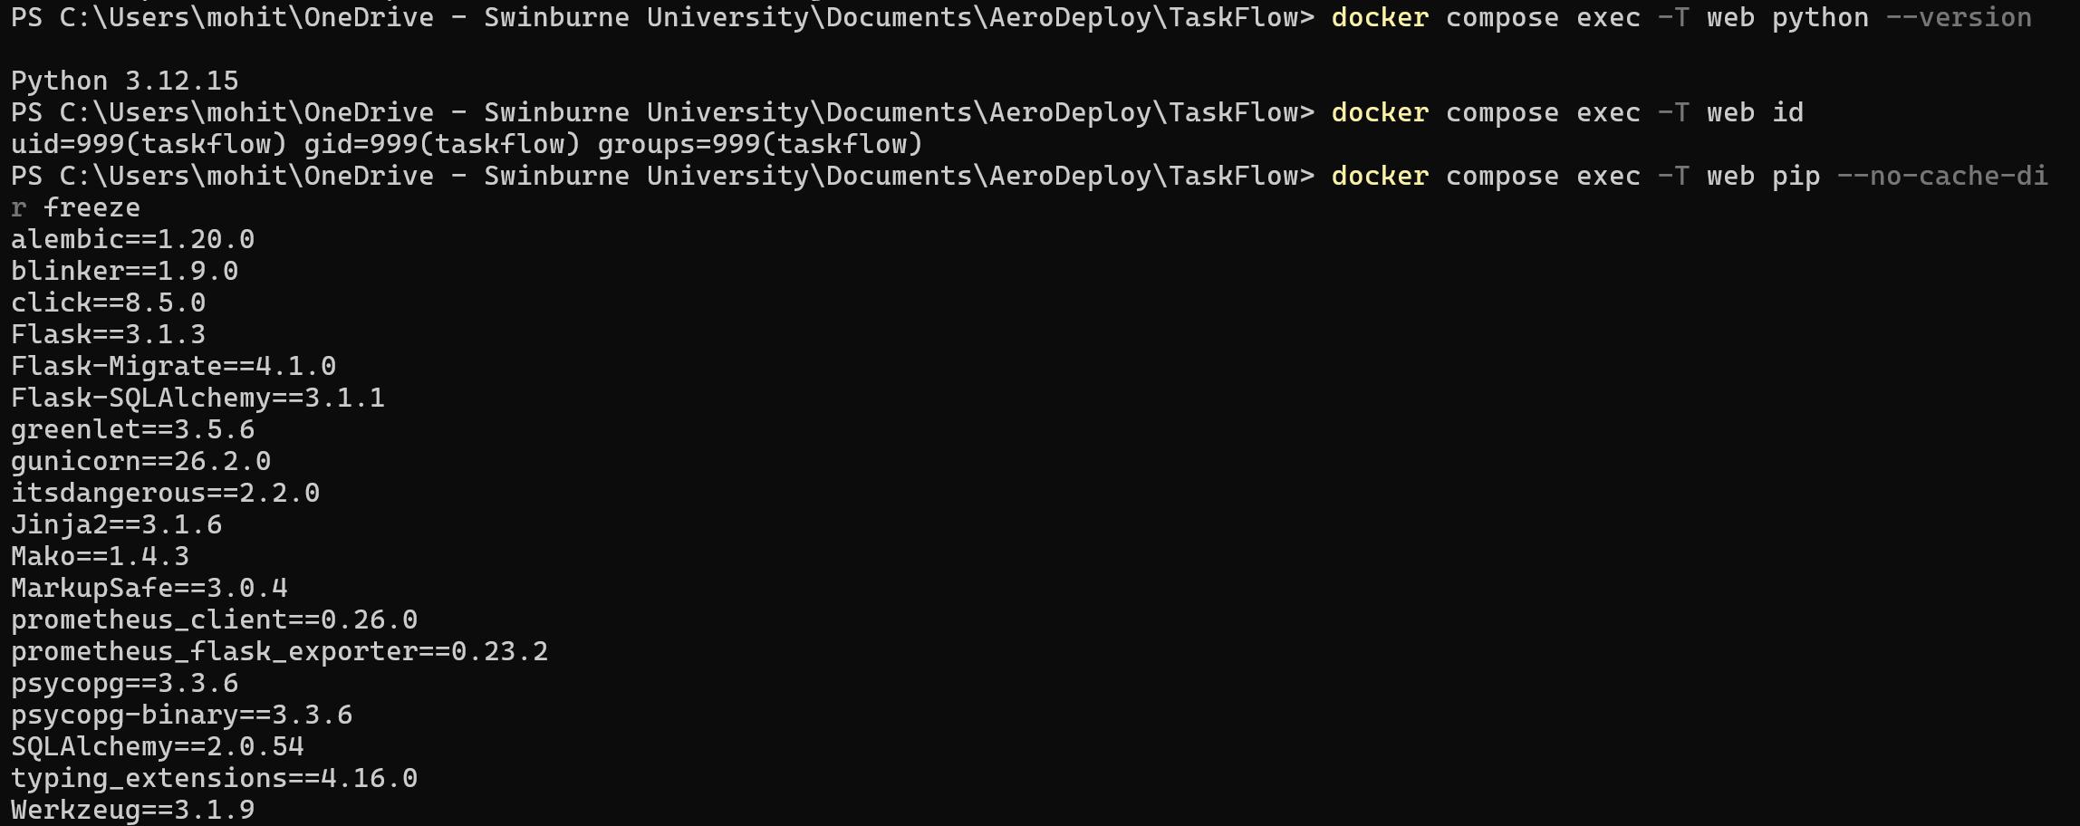
Figure 7(a): Container runtime verification showing Python 3.12.15, the non-root taskflow account and installed dependencies.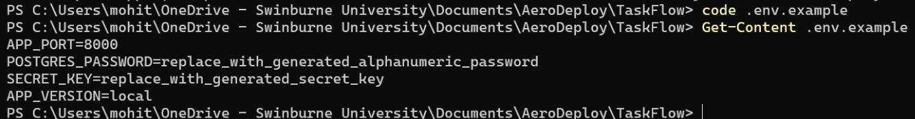
Figure 7(b): Example local environment configuration showing port 8000, credential placeholders and the application version setting.
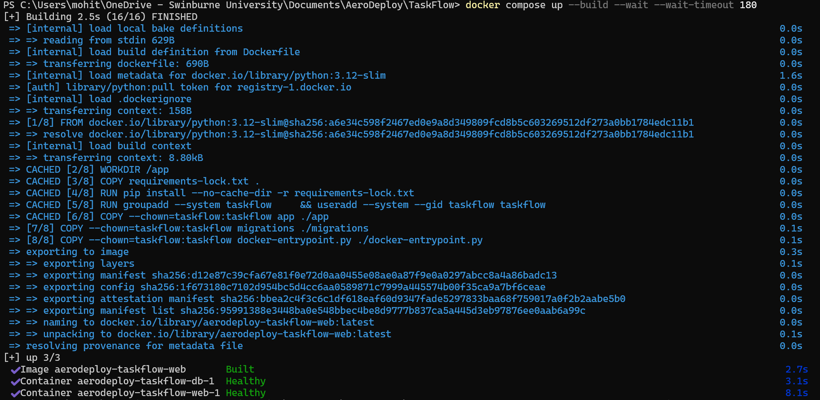
Figure 7(c): Successful local container build including database migrations and the startup script, with both application and PostgreSQL services reporting healthy.
Database Models and Migrations
We implemented Project and Task models, with each task linked to a project. The database stores task details, status, priority and an optional due date. Constraints protect required fields and supported values, while the project relationship supports deletion of associated tasks.
Migration 41a8c3c36f29 created the application tables. We verified that it was at the migration head and confirmed the presence of projects, tasks and alembic_version. A separate fresh-database check showed the migration running automatically before Gunicorn started, with startup completing successfully.
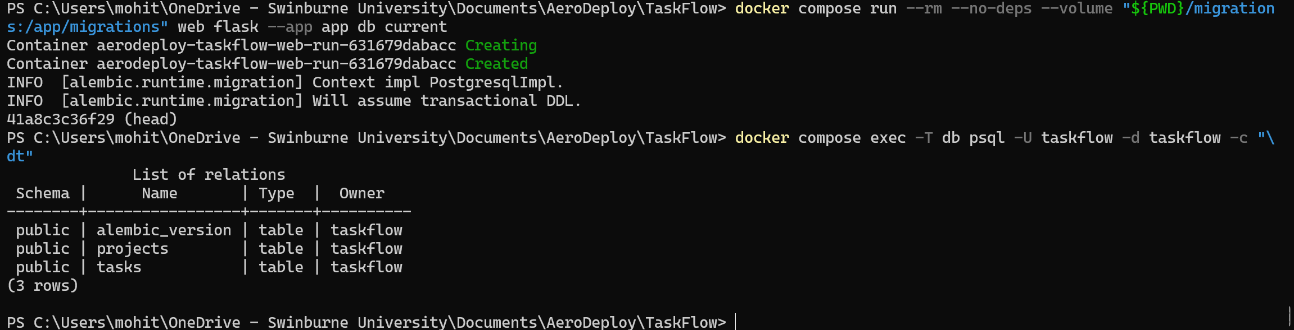
Figure 8(a): Database verification showing migration 41a8c3c36f29 at head and the projects, tasks and alembic_version tables.
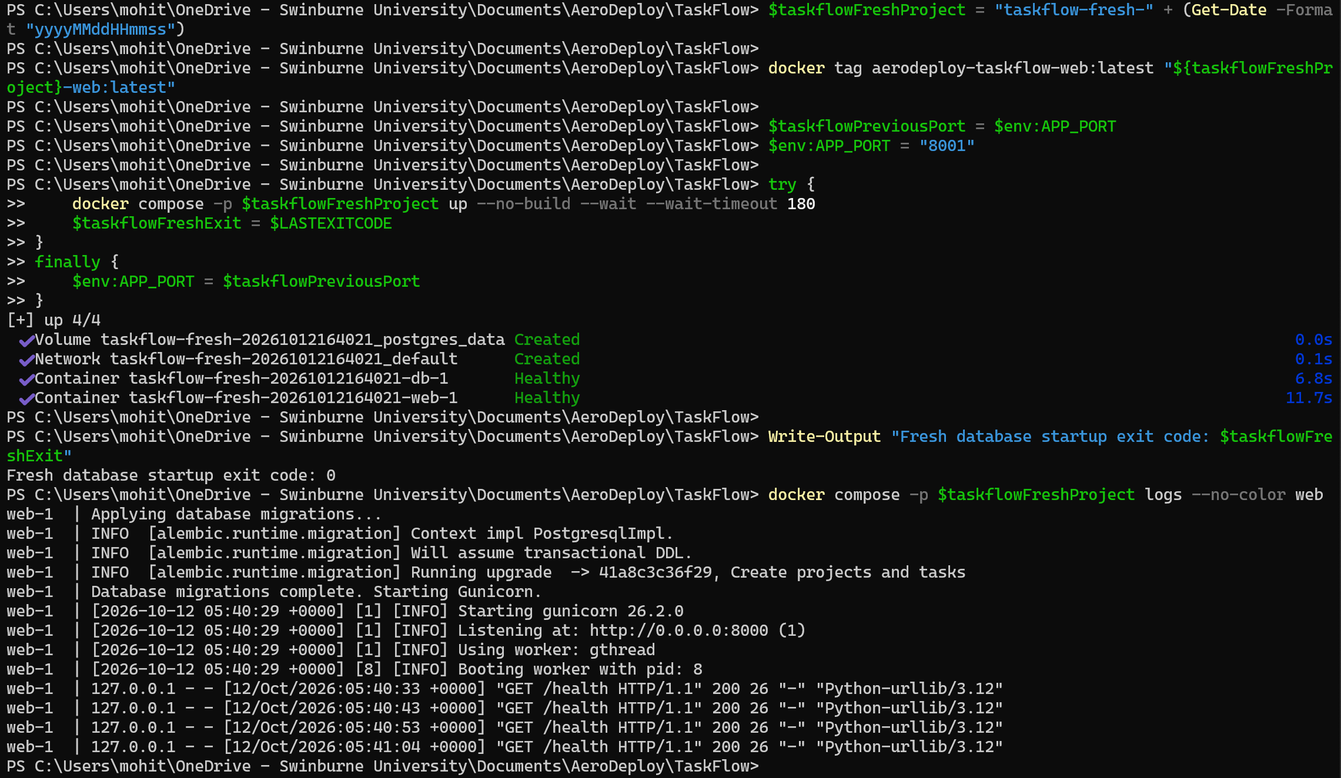
Figure 8(b): Fresh-environment startup showing exit code 0 and automatic database migration completing before Gunicorn starts.
Project and Task Functionality
We implemented project creation and task creation, editing and deletion. Tasks support To do, In progress and Done statuses, three priority levels and optional due dates. Server-side validation checks required fields, length limits, supported values and dates. Invalid submissions display an error and retain the entered information so that users can correct it.
Browser checks showed a task being created and then updated to Done. An empty task title was rejected. We also checked the confirmation and deletion of a separate temporary task while retaining the completed task.
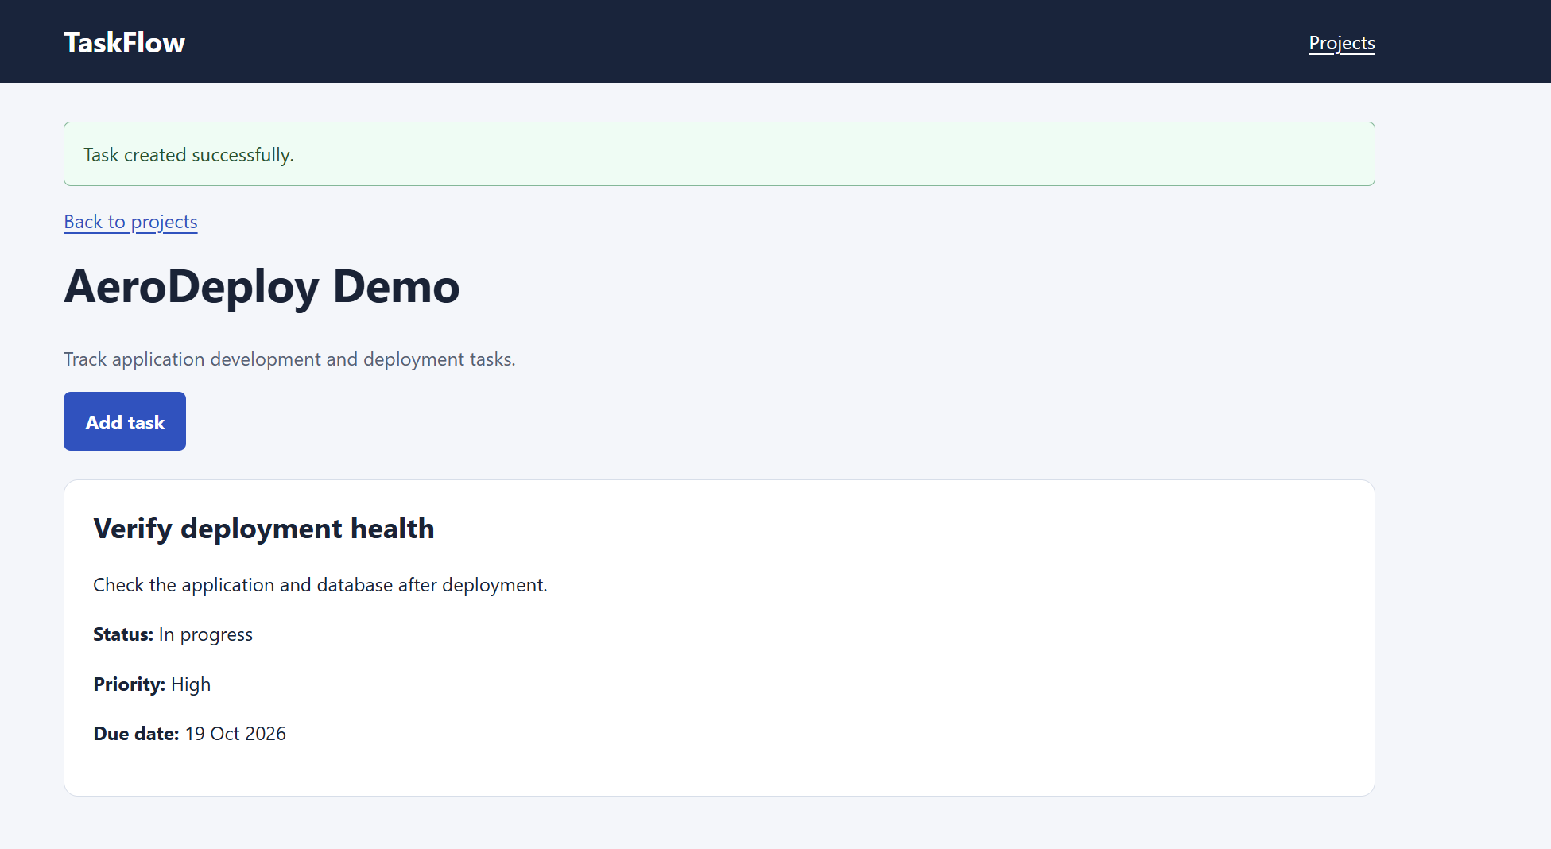
Figure 9(a): Successful task creation, showing the saved task details within AeroDeploy Demo.
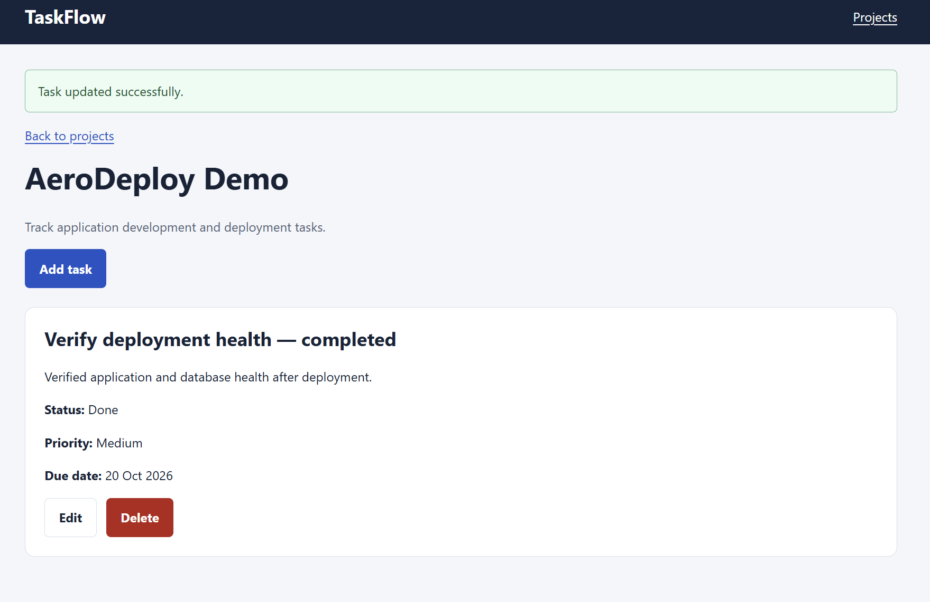
Figure 9(b): Successful task update, showing the task’s status changed to Done.
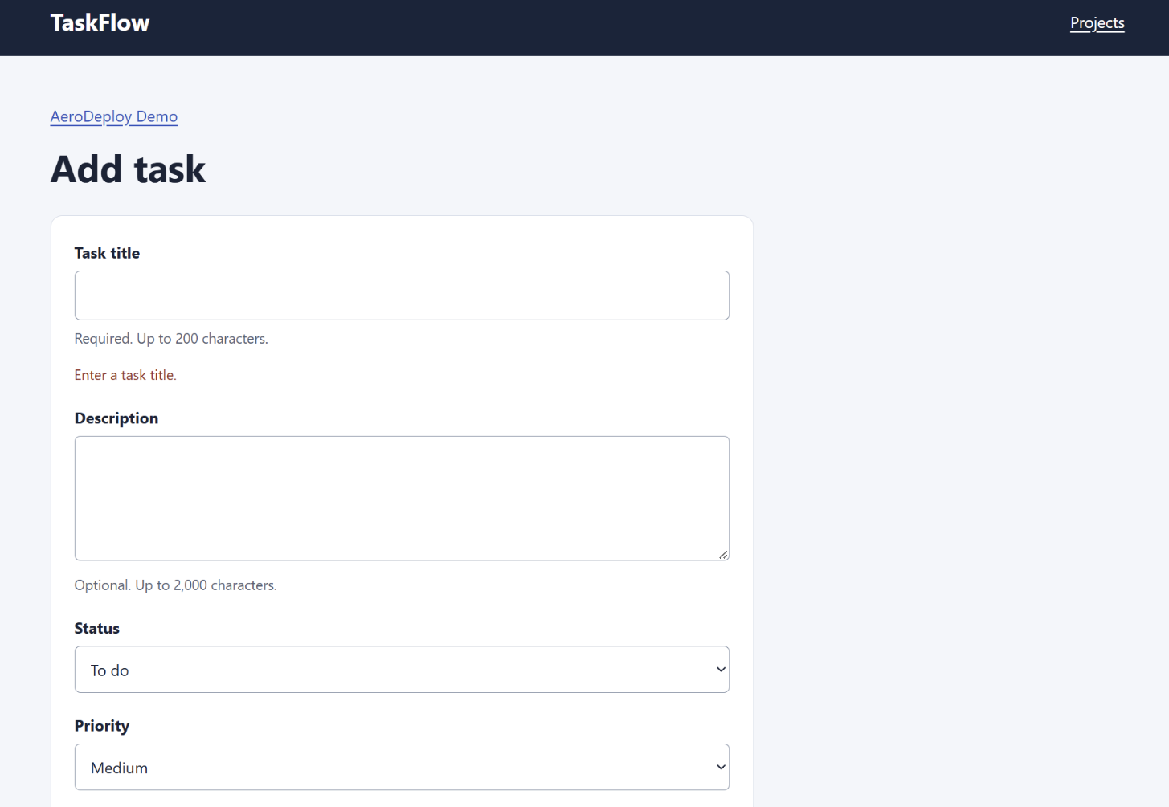
Figure 9(c): Required-field validation displaying an error when the task title is left empty.
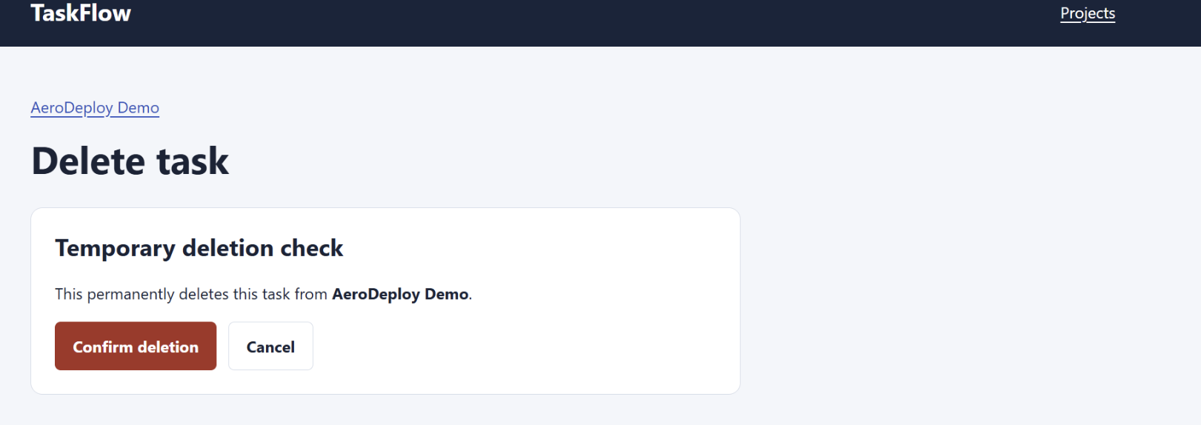
Figure 9(d): Confirmation page for deleting the “Temporary deletion check” task, with options to confirm or cancel.
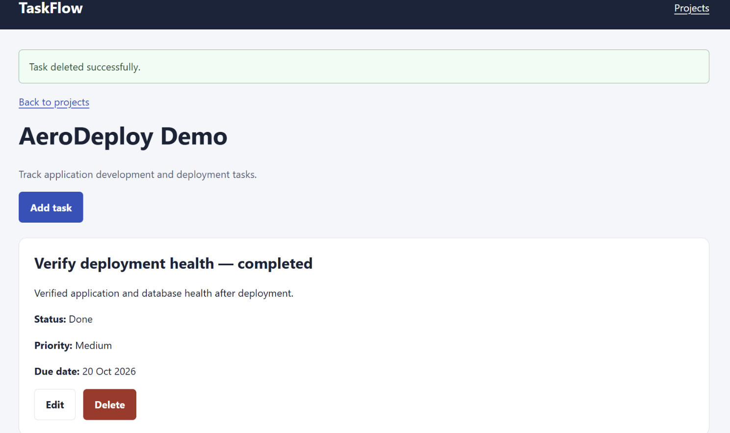
Figure 9(e): Successful deletion of the temporary task, with the other completed task remaining visible.
We added project deletion so that users could remove an unwanted project. Its confirmation page explains that the project and its tasks will be deleted. The browser evidence shows the unwanted project being removed while AeroDeploy Demo remains available.
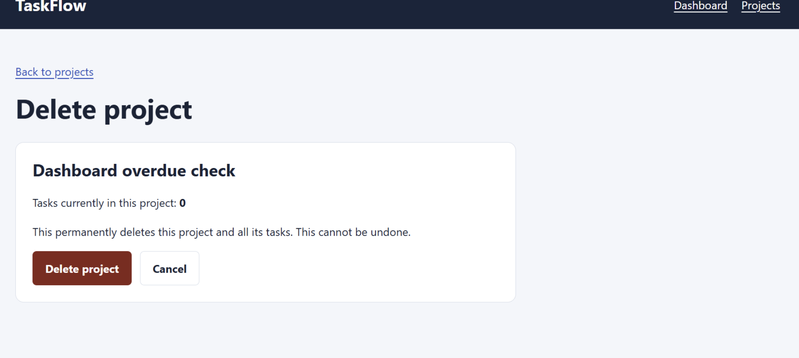
Figure 10(a): Confirmation page for deleting the “Dashboard overdue check” project, with options to delete or cancel.
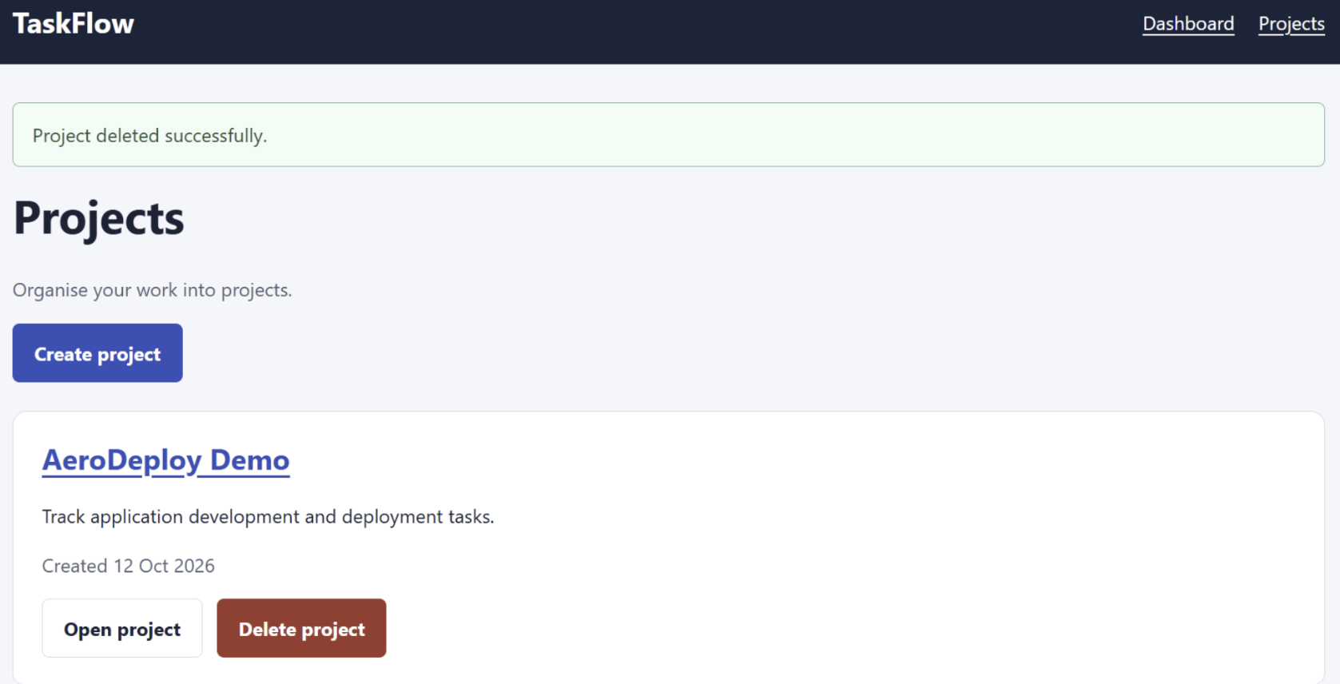
Figure 10(b): Successful deletion of the unwanted project, with AeroDeploy Demo remaining in the project list.
Dashboard, Navigation and Responsive Layout
The dashboard displays project and task totals, counts by status and overdue tasks. An overdue task is unfinished and has a due date earlier than the current UTC date. We checked an overdue example and verified the completed state shown in Figure 1, where all three tasks were Done and no tasks were overdue.
Dashboard and Projects links allow users to move between pages without changing the URL manually. We also inspected the project page and task form at a 350 × 768 viewport. The captured layouts show readable fields and controls fitting within the available width. These were manual visual checks rather than automated browser acceptance tests.
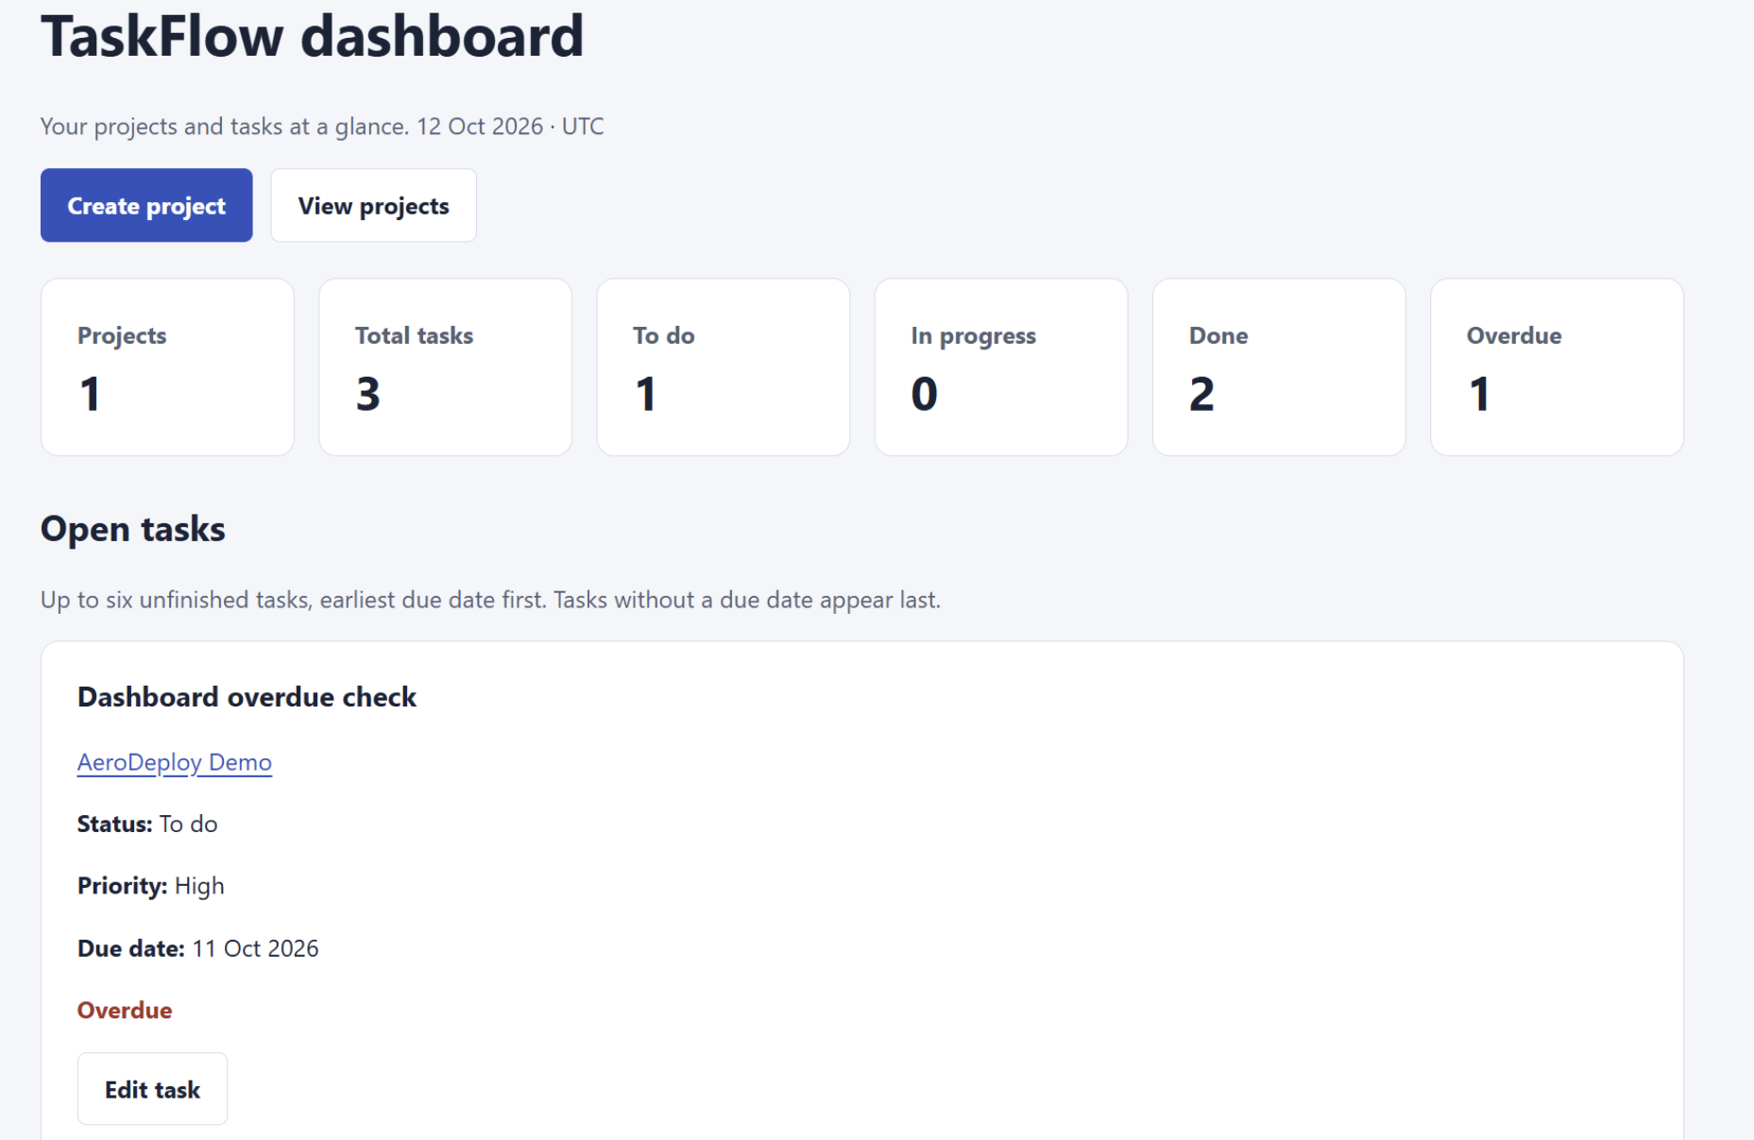
Figure 11(a): Dashboard showing one overdue task and its task card, including its status, priority and due date.
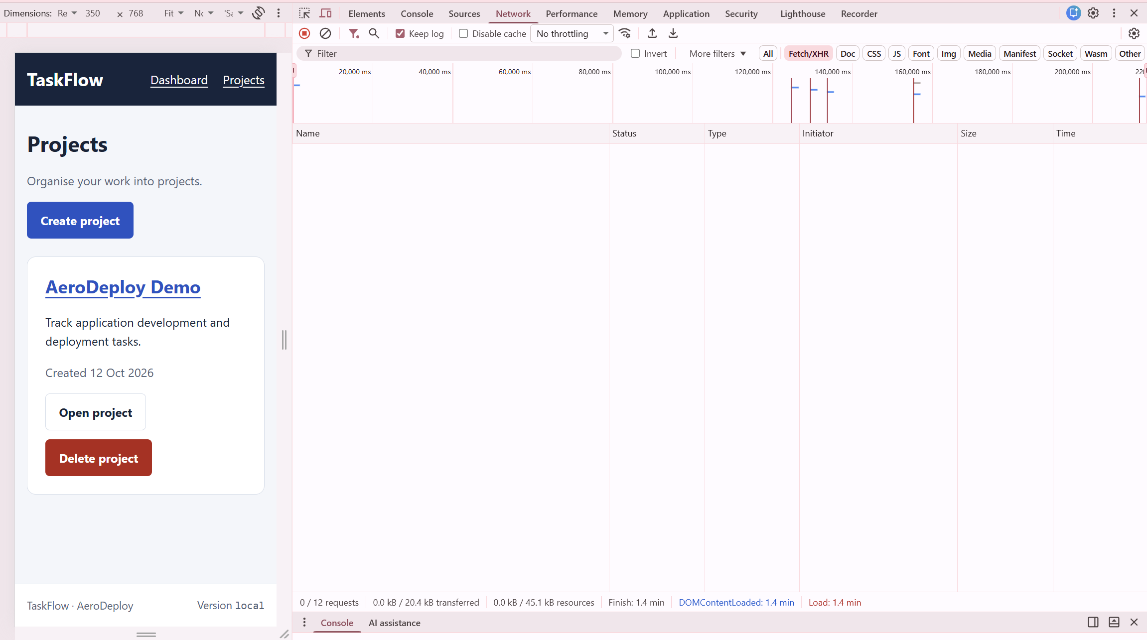
Figure 11(b): Projects page at a 350 × 768 viewport, showing readable project information and vertically stacked action buttons.
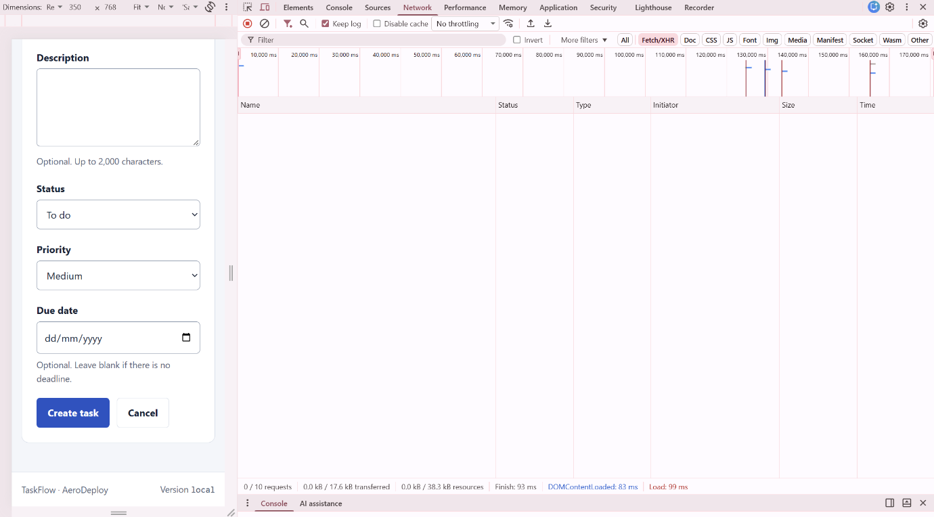
Figure 11(c): Lower section of the Add task form at a 350 × 768 viewport, showing the due-date field and accessible Create task and Cancel buttons.
Health Checks and Database Recovery
The /health endpoint checks the application’s database connection. When we stopped PostgreSQL, the endpoint returned HTTP 503 with the database reported as unavailable. After restarting the services, it returned HTTP 200 with both database and application status reported as healthy. This demonstrated that the health check responded to database availability.
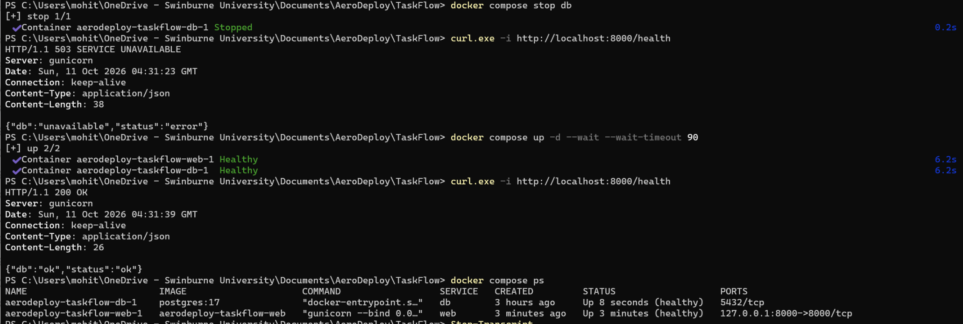
Figure 12: Database-aware health verification showing HTTP 503 while PostgreSQL is stopped and HTTP 200 after the database service recovers.
Stored-Data Persistence
We checked persistence using the project “Persistence check” and task “Retain task after restart”. The task had an In progress status, High priority and a due date of 19 October 2026. Queries returned the same identifiers and stored values before and after restarting the services.
We then forced container recreation. The container identifiers changed, but the same project and task remained in the database. These results demonstrate local persistence when the named PostgreSQL volume is retained.
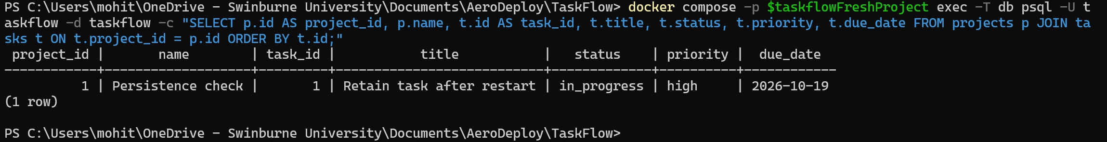
Figure 13(a): Database query showing the persistence-check project and task before restarting the services.
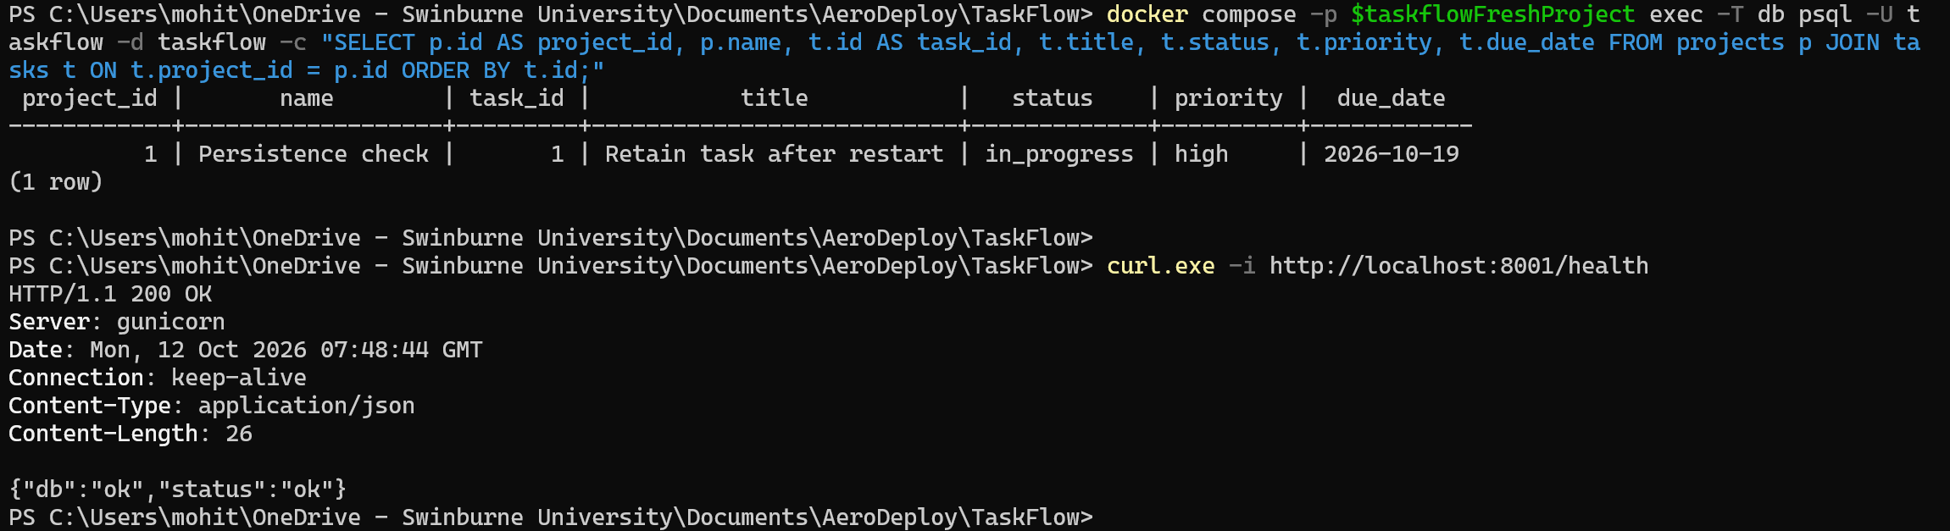
Figure 13(b): Database query confirming the same record after service restart, followed by a successful health response.
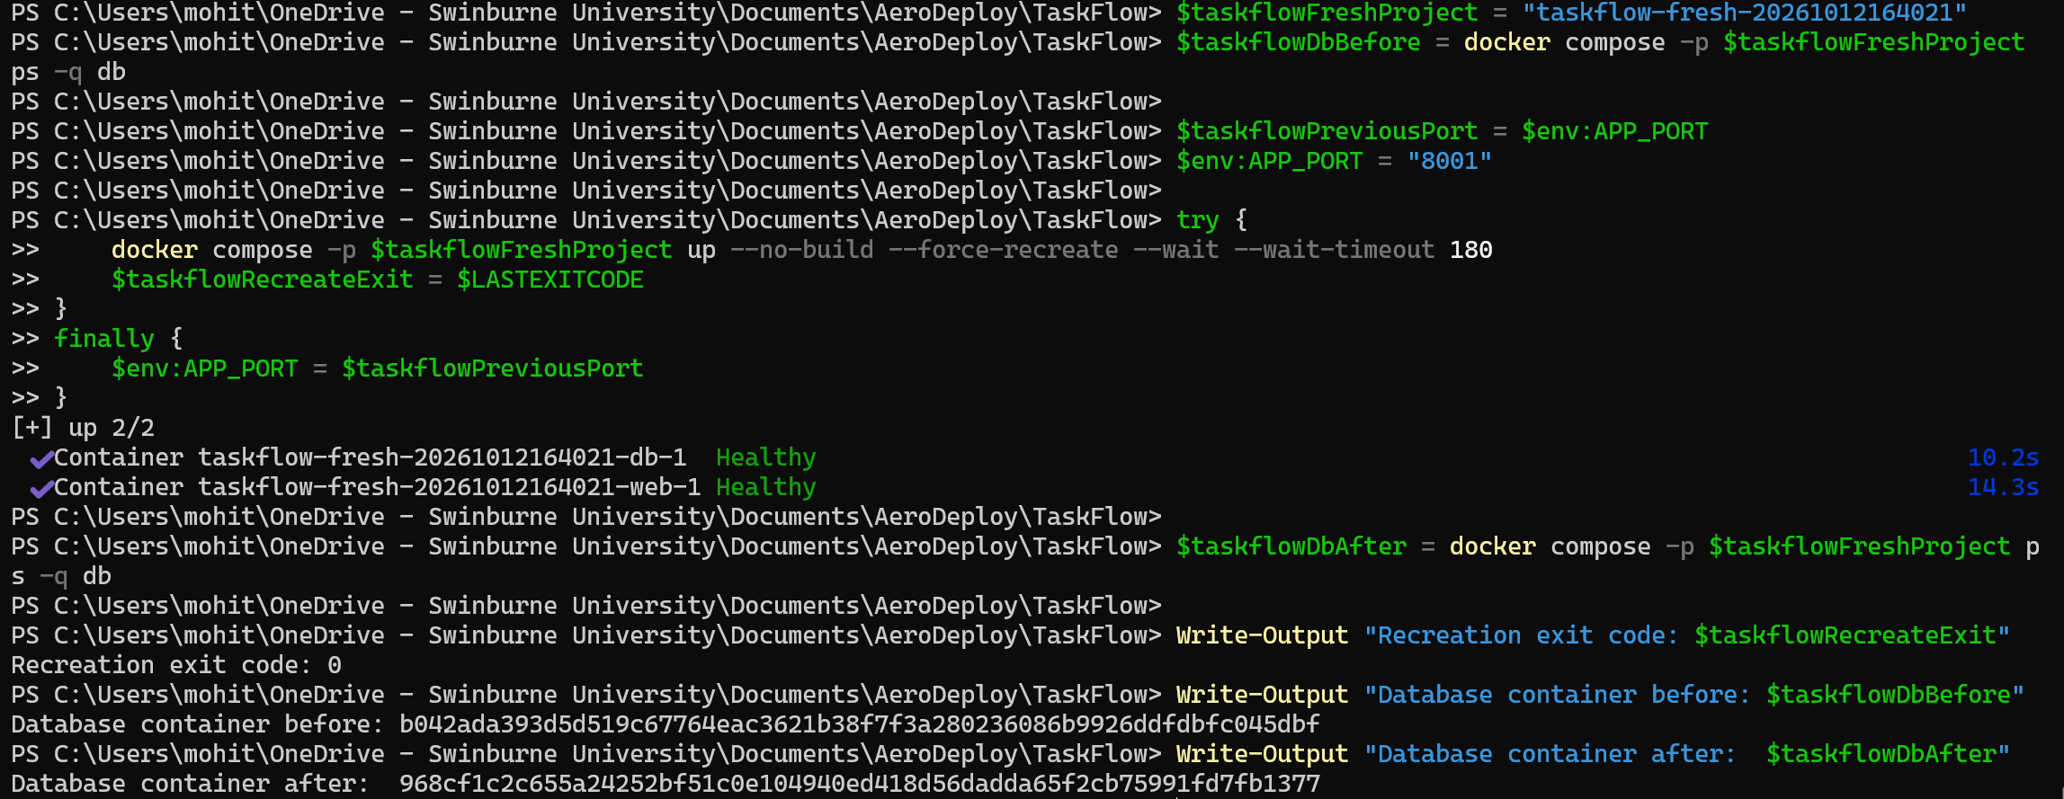
Figure 13(c): Successful forced container recreation, showing changed database container identifiers and healthy services after replacement.
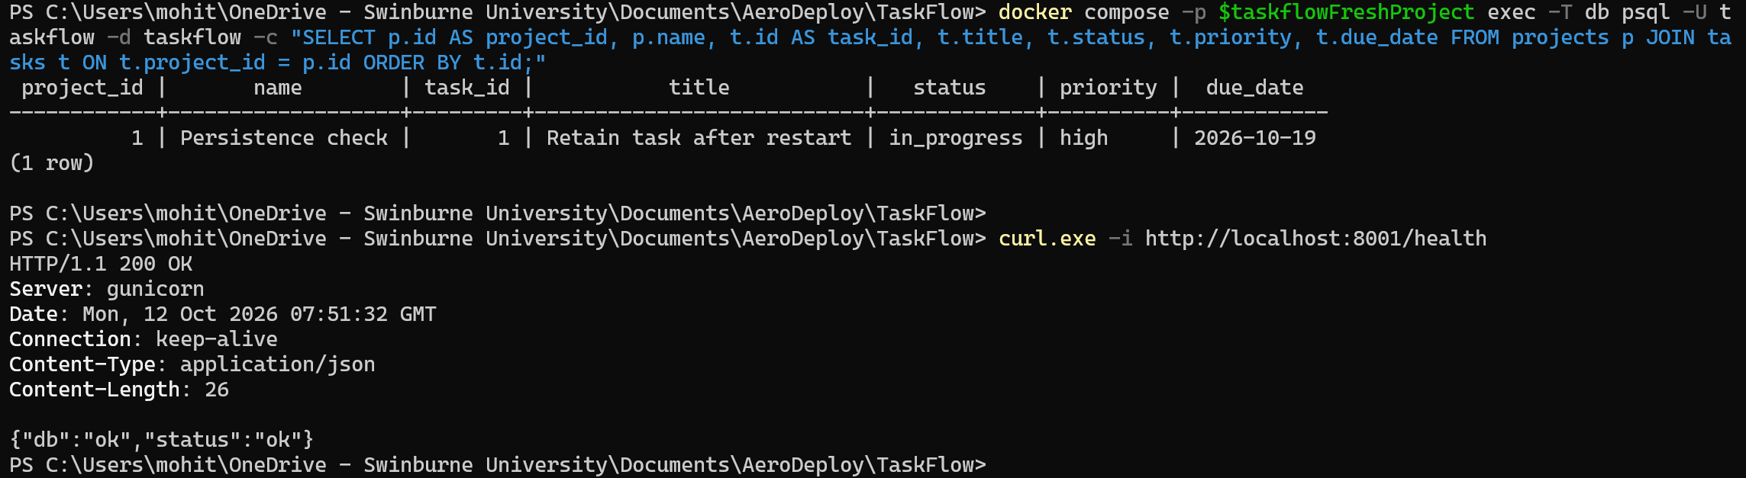
Figure 13(d): Database query confirming that the same project and task remained after container recreation, with a successful health response.
Local Automated Tests and Coverage
We ran the automated tests in a separate PostgreSQL test environment to avoid changing the normal application dataset. The suite checked validation, database operations, project and task routes, dashboard behaviour and supporting endpoints.
The recorded run passed 15 unit tests and 33 integration tests, giving 48 passing test methods. It also reported 95 passing subtests. Application statement coverage reached 99.64%, representing 275 of 276 statements and exceeding the configured 80% threshold. Both the test process and cleanup completed with exit code 0.
The coverage result applies to the measured Python application statements. It does not establish coverage of browser interactions, container deployment or production operation.
The integration tests also checked that form submissions with missing or incorrect security tokens were rejected. These tokens help protect against cross-site request forgery, where another website attempts to submit a form on a user’s behalf. We also checked that user-entered text was escaped when displayed, so it appeared as text instead of being interpreted as HTML.

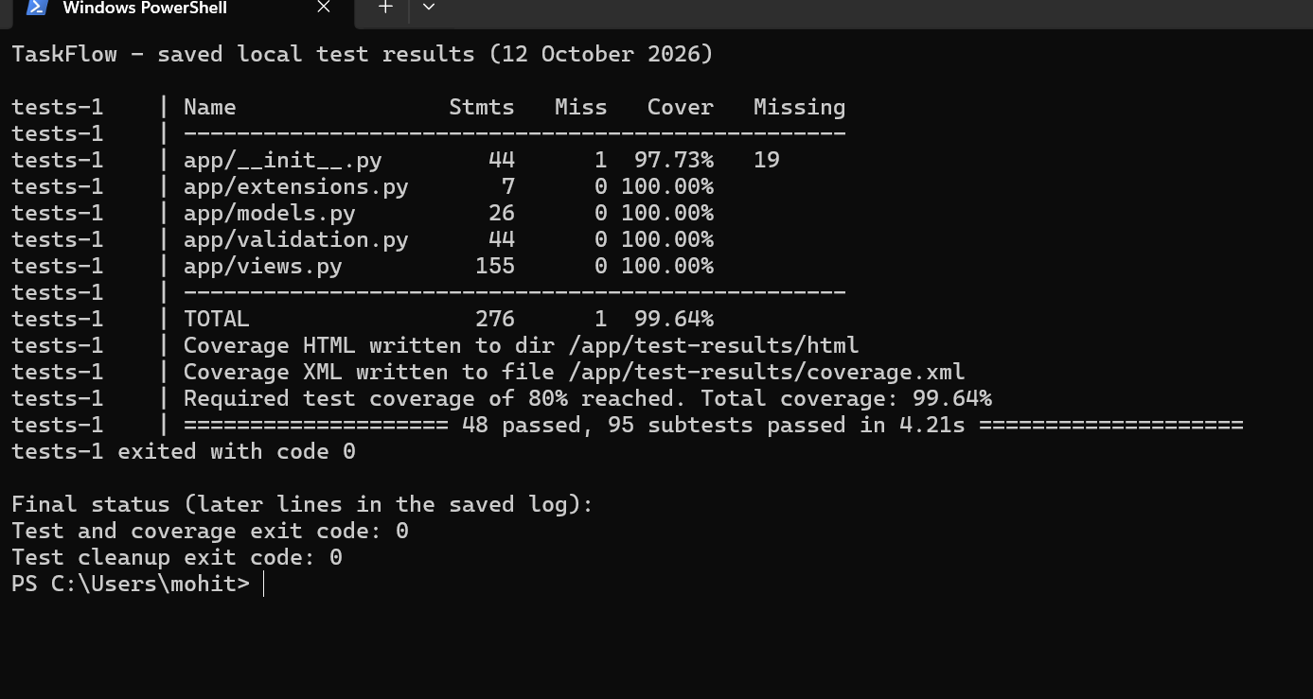Figure 14: Saved local test results displayed in PowerShell, showing 48 passing test methods, 95 passing subtests and 99.64% application statement coverage, with test execution and cleanup completing with exit code 0.
Automated Test Execution on the Test/Staging Server
The deploy-staging job runs after the build job has published the new image to GitHub Container Registry. It is controlled by the STAGING_READY repository variable, which allowed the rest of the pipeline to operate before the staging server was ready; the variable was enabled once the server and its secrets were in place. The job connects to the staging VM over SSH using the pipeline key and server details stored in GitHub Secrets (STAGING_HOST, STAGING_SSH_KEY and STAGING_DB_PASSWORD).
The remote-deploy.sh script copies the Compose file and deployment scripts to /opt/aerodeploy and writes the environment settings for the release, including the image tag set to the commit SHA. The deploy.sh script then pulls that image, starts the application and its own PostgreSQL 17 database with Docker Compose, and checks /health every five seconds for up to one minute. If the application does not become healthy, the previous image and settings are restored and the job fails.
Because staging runs the same image that production will later receive, a failure here reflects the release that would otherwise have been deployed. The unit and integration tests, together with the 80% coverage gate, run earlier in the check job on the CI/Build server, as explained in Table 2. The Test/Staging server adds the browser-level acceptance tests described below, which require the complete deployed application and database.
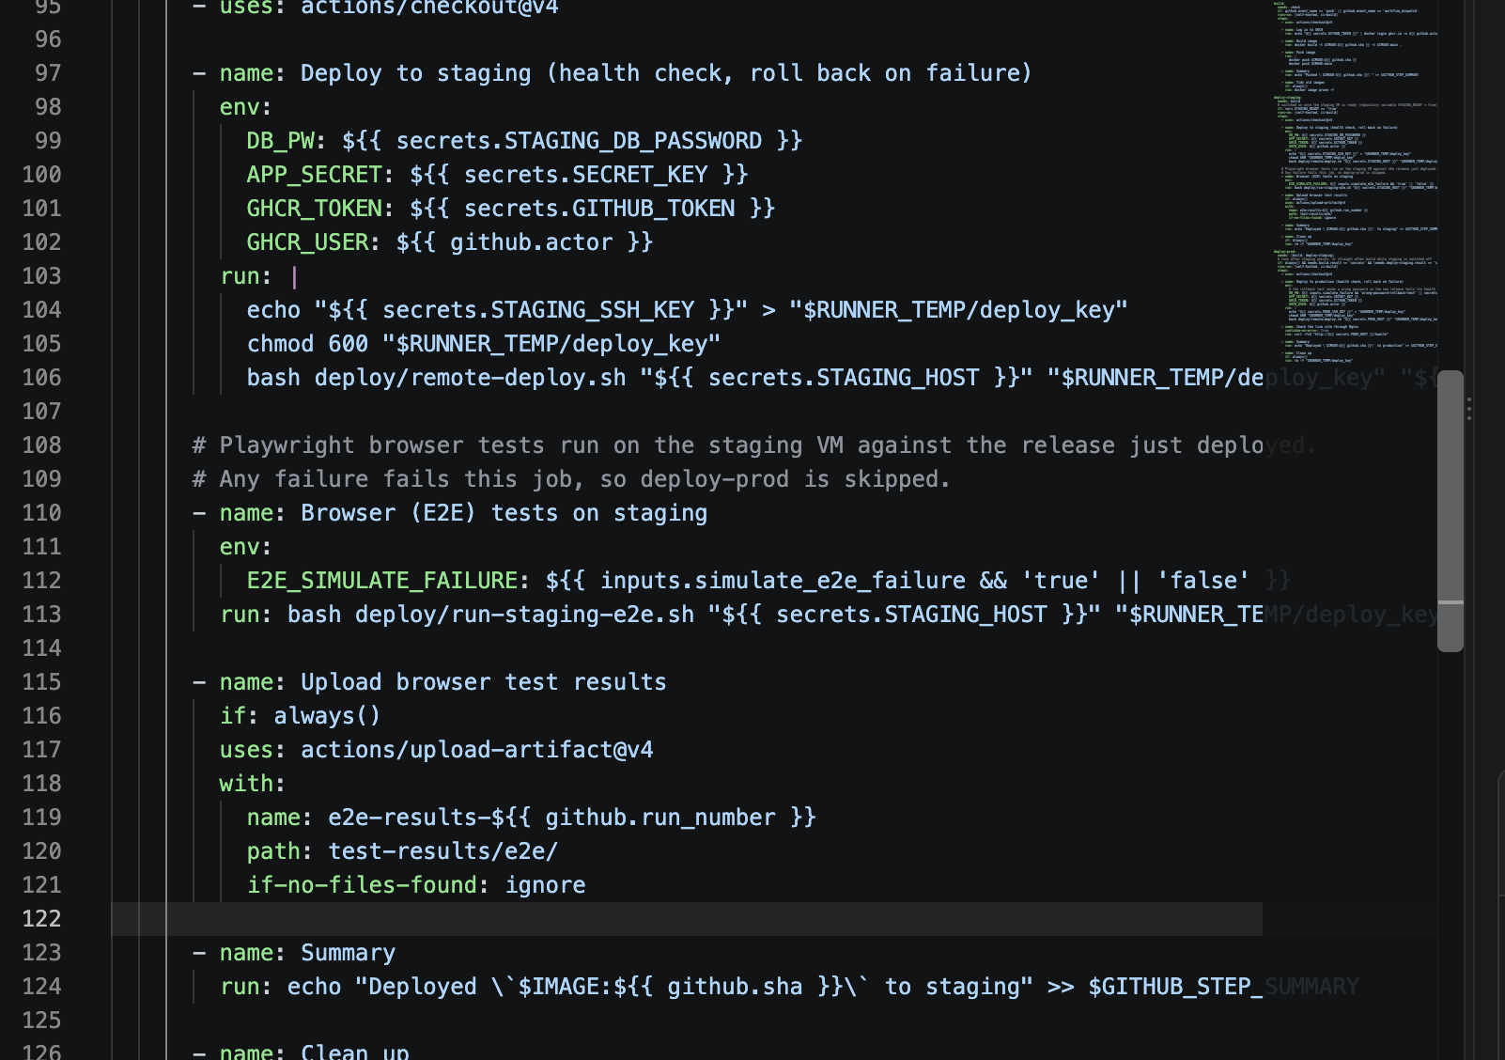
Figure X: The deploy-staging steps in pipeline.yml: deployment with health check and rollback, the browser tests, and the upload of their results.
End-to-End Acceptance Testing
We wrote eight end-to-end acceptance tests using Playwright for Python with pytest. Each test drives a real Chromium browser against the application deployed on staging and checks the result as a user would see it. Table 5 summarises the tests.
Table 5: End-to-end acceptance tests run on the Test/Staging server.
Test file | Tests | What is checked
test_smoke.py | 3 | The /health endpoint reports the application and database as healthy; staging is running the commit under test (version from /api/info and the page footer); the dashboard and navigation load.
test_task_flow.py | 2 | A user can create a project, add a task, change its status, and delete the task and the project; a task with a past due date appears as overdue on the dashboard.
test_validation.py | 2 | A blank project name and a task title containing only spaces are rejected with the correct error message.
test_demo_switch.py | 1 | Fails on purpose when the simulate_e2e_failure option is selected, to demonstrate the production gate.

The tests locate page elements by their visible labels and roles, such as the "Add task" button, rather than by internal HTML identifiers, so they follow the user's view of the page. Each run creates records with unique names and deletes them afterwards, so repeated runs do not leave test data behind or depend on earlier runs. The version test compares the deployed version with the commit SHA supplied by the pipeline, confirming that staging is running the exact build being promoted.
The tests run inside the pinned Playwright container on the staging VM. The run-staging-e2e.sh script, executed by the pipeline, copies the test files to the server over SSH and starts run.sh, which launches the container with host networking so that it can reach the application on 127.0.0.1:8000. Tool versions are pinned (Playwright 1.63.0, pytest 9.1.1 and pytest-playwright 0.9.0) so that results are repeatable. pytest writes a JUnit XML report and keeps a Playwright trace for any failing test; these are copied back and uploaded as the e2e-results pipeline artifact.
The job's result controls promotion. If all eight tests pass, deploy-prod runs; if any test fails, the job fails and deploy-prod is skipped, so production keeps its previous version. For the demonstration, a simulate_e2e_failure option in the manual Run workflow form makes one test fail on purpose so that this behaviour can be shown on request.
Before submitting the tests, we verified them locally against a running copy of TaskFlow. A normal run passed all eight tests, the demonstration switch produced the expected failure, a mismatched expected version was detected, and no test projects remained after the runs. The tests and pipeline step were submitted in pull request #7 (feature/staging-e2e-tests). Its check run (#18) passed, and the merged change ran successfully on main in run #19 on 19 October.
The gate was also exercised by a real change. On 20 October, a pull request updating the dashboard heading for the demonstration passed its checks, but after it was merged, run #28 failed because the smoke test expected the exact heading text "TaskFlow dashboard" and no longer found it. Production was therefore not updated. The test was changed to check that the heading contains the title rather than matching it exactly, and run #30 deployed the change to production successfully. This showed the gate stopping a release that did not match the tested expectations, although in this case the cause was an overly strict test rather than an application fault.
Production Deployment and Live Application Verification
On the production VM, Nginx acts as a reverse proxy: it listens for public requests on port 80 and forwards them to the application on 127.0.0.1:8000. Because the application port is bound only to the VM’s local interface, it cannot be reached directly from the internet, and Nginx is the single public entry point.
After the pipeline’s first production deployment on 19 October, TaskFlow loaded successfully in the browser at http://20.70.170.224.
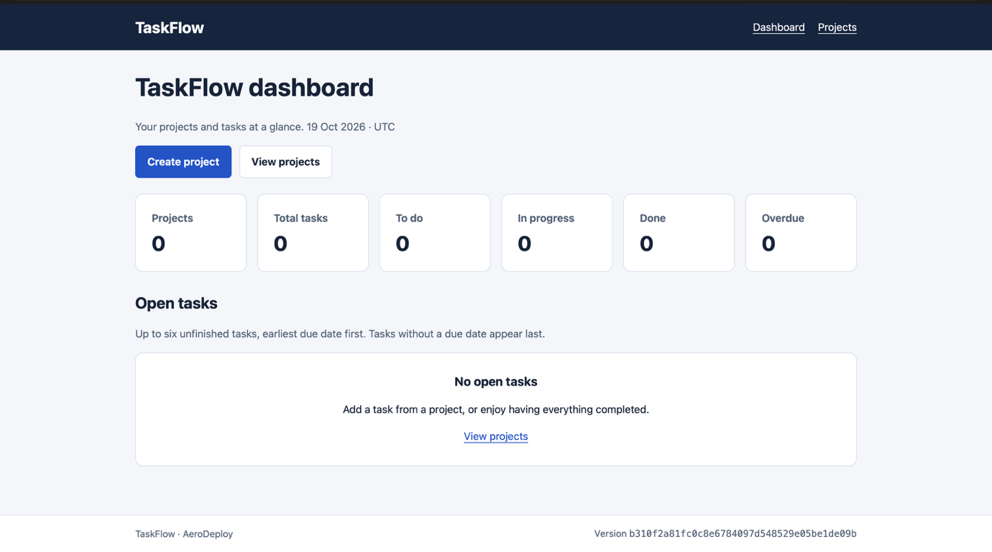Figure x(a): TaskFlow served from the production VM after the first pipeline deployment.
We also checked the application’s health and metrics endpoints through Nginx. The /health endpoint confirmed that both the application and its database connection were healthy, and the /metrics endpoint returned the request measurements that Prometheus collects.
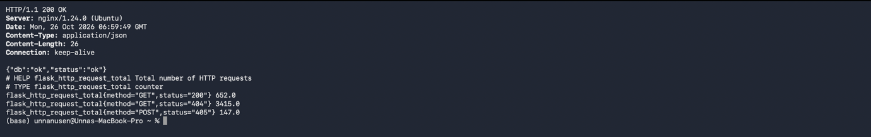Figure x(b): /health and /metrics responses from the production application.
Production Database and Persistence Verification
In Production, the PostgreSQL 17 database runs in its own container and stores its data in a named Docker volume. Keeping the data in a volume separates it from the container’s lifecycle, so the container can be replaced during deployments without losing stored records.
To test persistence, on 14 October we inserted a test row into a persist_test table, forcibly removed the database container with docker rm -f and recreated it. The test row was still present after recreation, confirming that the data is stored in the volume rather than inside the container. This row also appears in the backup restored on 16 October (Figure 12(b)), showing that it survived the container’s removal. This test was carried out on the initial manually deployed database; when the pipeline later took over deployments, it created a new database container and volume under the project name aerodeploy-taskflow.
We also configured an automated nightly backup. The backup-db.sh script uses pg_dump to export the database to a .sql file and keeps the seven most recent backups, deleting older ones. A cron job runs the script every day at 16:00 UTC, which is 3:00 am in Melbourne, when the application is least likely to be in use.
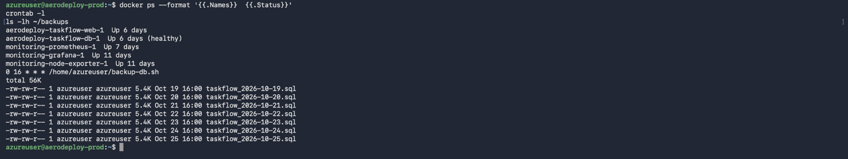Figure 12(a): Nightly backup schedule and the seven most recent backup files.
To confirm the backups could actually be used, we restored one into a separate restore_test database and queried the persist_test table, which returned the expected row. Restoring into a separate database avoided any risk to the live data. After the check, the test database was removed.
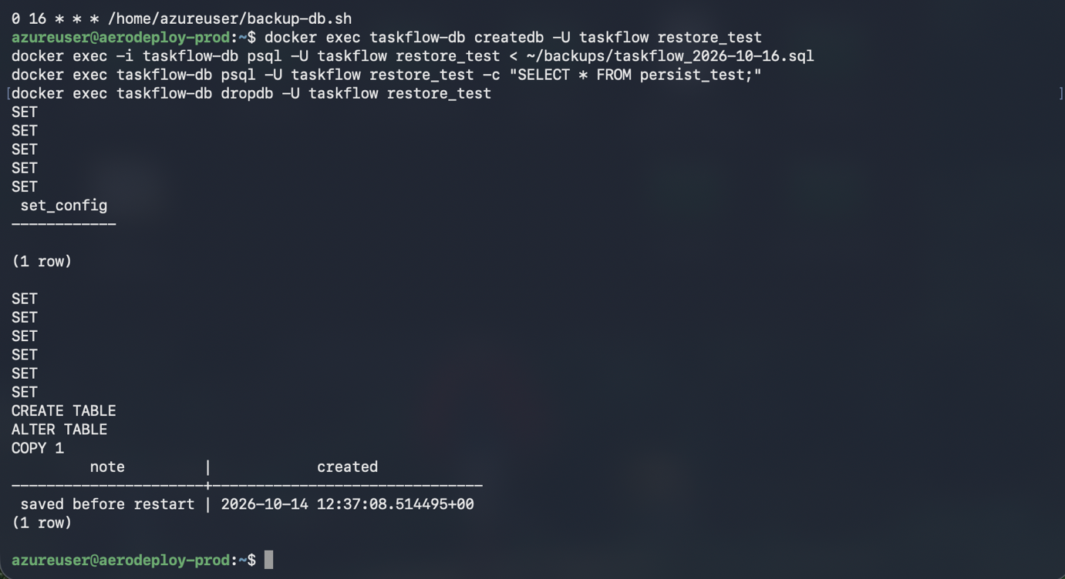Figure x(b): A backup restored into the restore_test database, showing the persist_test row.

3.4 Level 4: Full Pipeline Automation
Repository Trigger and Automated Build
Automated Test and Coverage Gates
Container Image Publication and Promotion
Automated Production Deployment and Health Checks
Visible Source Change and Deployed-Version Verification
Deployment Failure Handling and Recovery

4. Troubleshooting & Problem Resolution

4.1 Docker Compose Configuration
During local setup, Docker Compose validation failed because SECRET_KEY was missing from the environment file. The command returned exit code 1 and identified the missing variable. We added a generated value to the local .env file and repeated the configuration check. It then returned exit code 0. This showed why environment settings should be validated before starting the containers.
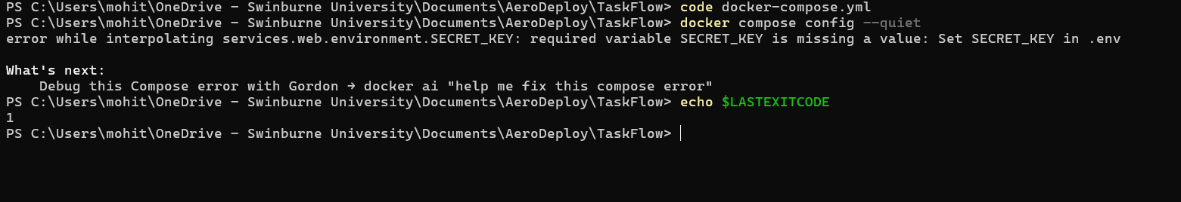
Figure 15(a): Docker Compose validation failing because SECRET_KEY was missing, with exit code 1.
Figure 15(b): Successful Docker Compose validation after adding SECRET_KEY to the local environment file, with exit code 0.

4.2 Container Permission Errors
After introducing automatic migrations, the application logs showed a Gunicorn control-server permission error involving /home/taskflow. Health requests still returned HTTP 200, so the healthy status alone did not reveal the configuration issue. We disabled the unused control socket with --no-control-socket, rebuilt the container and checked its logs again. The subsequent startup completed without that error, while the application continued running as the non-root taskflow user.
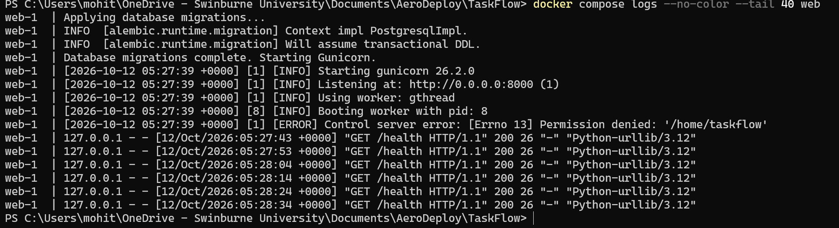
Figure 16(a): Gunicorn startup log showing a control-server permission error involving /home/taskflow, while health requests still returned HTTP 200.

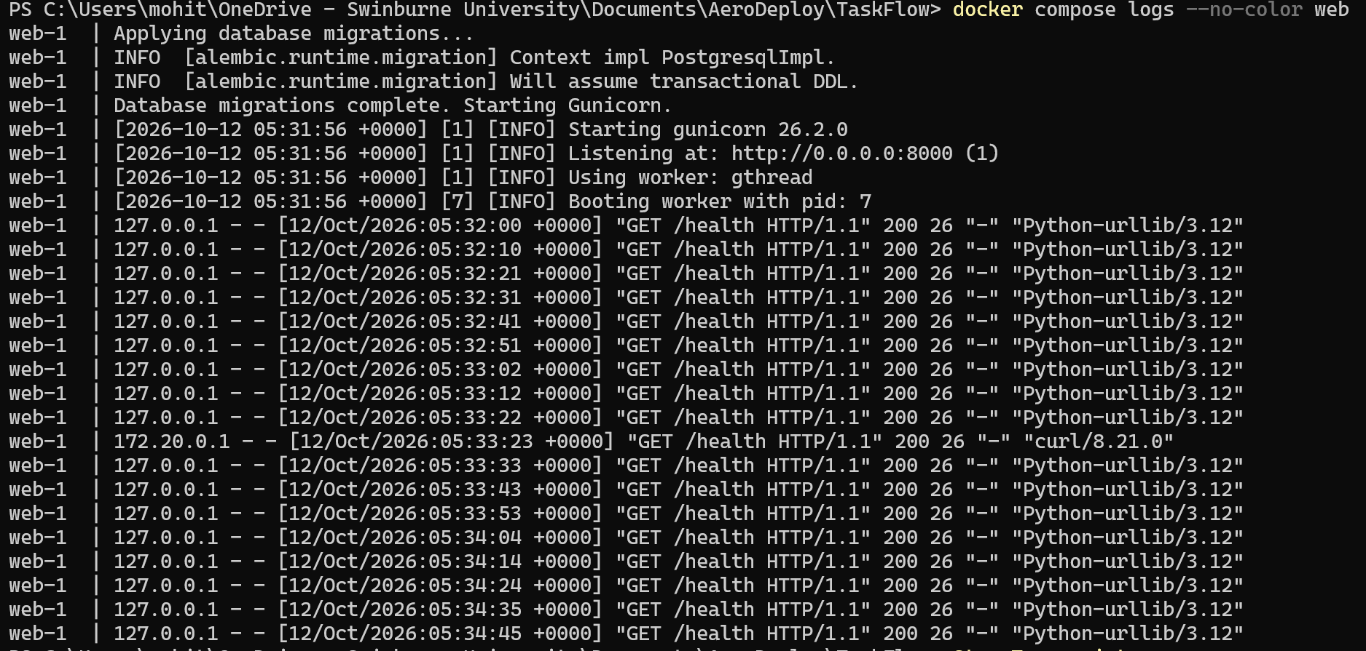
Figure 16(b): Gunicorn startup log after disabling the unused control socket, showing no recurrence of the permission error and successful HTTP 200 health responses.
A separate warning appeared when exporting installed dependencies because pip could not write to its cache directory. We repeated the export with --no-cache-dir and checked the resulting dependency lock file. This removed the warning without changing the container’s user permissions.
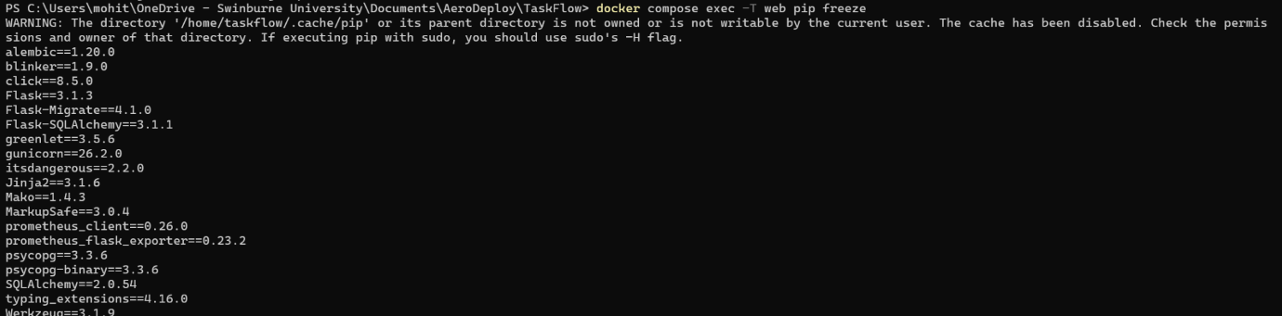
Figure 17(a): Pip cache-directory permission warning encountered while exporting installed dependencies as the non-root user.
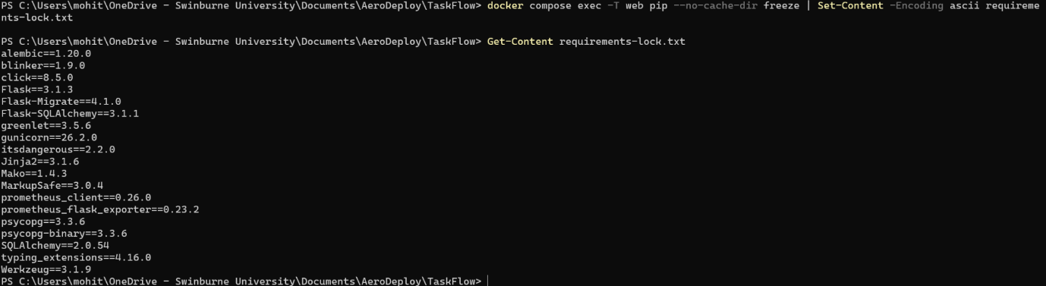
Figure 17(b): Successful dependency export using --no-cache-dir, with installed package versions saved in requirements-lock.txt.

4.3 Projects Page Rendering Error
The Projects page returned HTTP 500 during the navigation and project-deletion changes. We inspected the application logs, corrected the view code and rebuilt the container. We then checked the dashboard and Projects routes again. The successful project-deletion workflow is shown in Figure 10. The retained evidence does not include the original traceback, so it does not establish the exact failing statement.
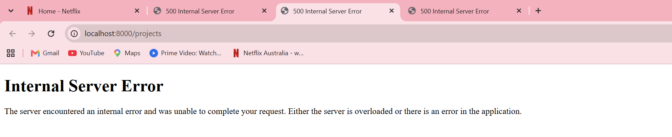
Figure 18: HTTP 500 error encountered on the local Projects page during navigation and deletion updates.
This issue showed that syntax checks and a successful health response must be supported by checks of the actual application pages.

4.4 Automated Test Assertion Failure
An integration test initially failed because it could not find the “Project deleted successfully.” message. The test opened another page before checking the redirect destination, which consumed the one-time message. We changed the request order so that the message was checked immediately after deletion. The checks for deleted records and preservation of the other project remained in place. The corrected test passed and Figure 14 shows the final successful suite.
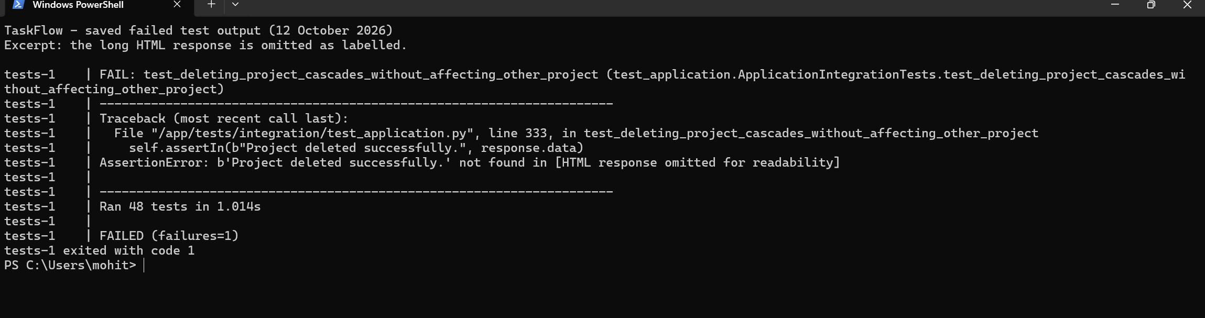
Figure 19: Saved integration-test output showing the missing project-deletion success message and exit code 1 before correcting the test’s request order. The returned HTML is omitted for readability.

4.5 Evidence Capture and Repository Checks
Some PowerShell transcripts saved commands and exit codes but omitted output from the test process. We therefore retained the full terminal output alongside the JUnit and coverage reports. Selected terminal and build outputs are provided in Appendix A and cross-referenced to the supporting figures.
Before committing, Git also identified trailing whitespace in the database migration file. We removed it, staged the corrected file and repeated the whitespace check successfully before committing and pushing the application.
These corrections were verified locally. Test/Staging execution, production behaviour and pipeline failure handling require separate verification in the team’s environments.

4.6 CI/Build and Test/Staging Troubleshooting
Test/Staging Server and End-to-End Tests
Resource group permissions. Creating a new resource group failed because our Azure for Students account did not have permission to create resource groups in the subscription. We created the staging VM in the team's existing aerodeploy-rg resource group instead, which also kept the three VMs together.
Unavailable VM size. Creating the VM with Standard_B2s_v2 returned a NotAvailableForSubscription error. The size could be used, but not with the availability-zone option selected by default. Changing Availability options to "No infrastructure redundancy required" allowed the VM to be created.
SSH key option. When adding the deploy user through the Reset password page, the SSH public key source was left on "Generate new key pair" and the pipeline key was pasted into the Key pair name field, which would have created a new key that the pipeline did not hold. We changed the source to "Use existing public key" and pasted the key into the public key field.
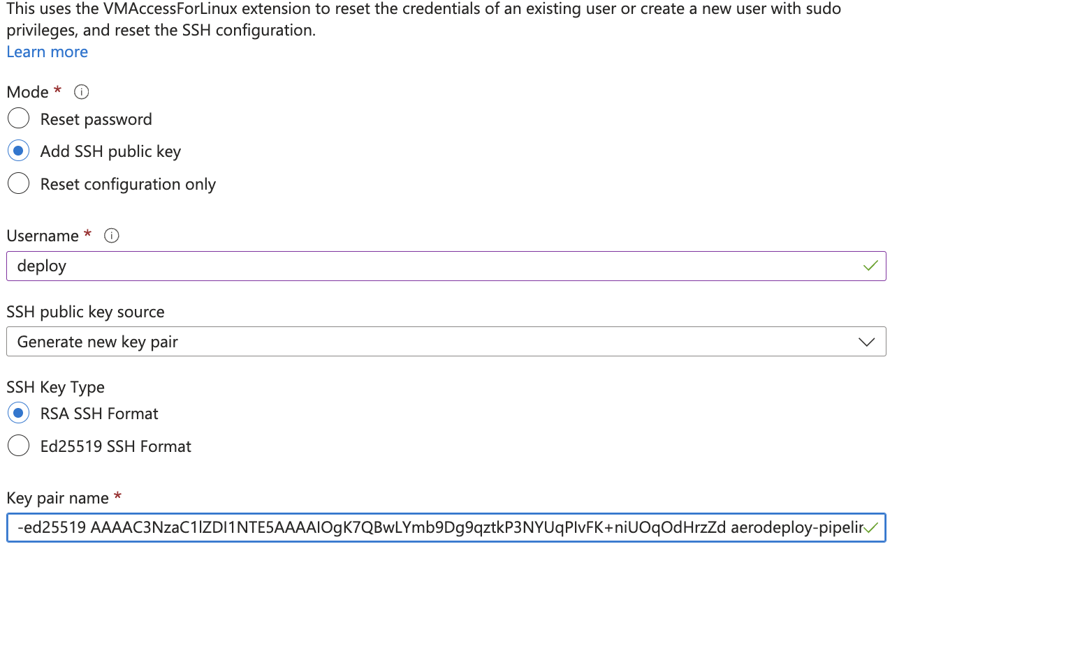
Figure X: The Reset password page with "Generate new key pair" still selected and the pipeline key pasted into the Key pair name field.
Auto-shutdown deployment failure. The VM was created, but the deployment reported a failure for the auto-shutdown schedule because the Microsoft.DevTestLab resource provider was not registered in the subscription. We referred this to the team member who manages the subscription, since registering a provider requires subscription-level rights.
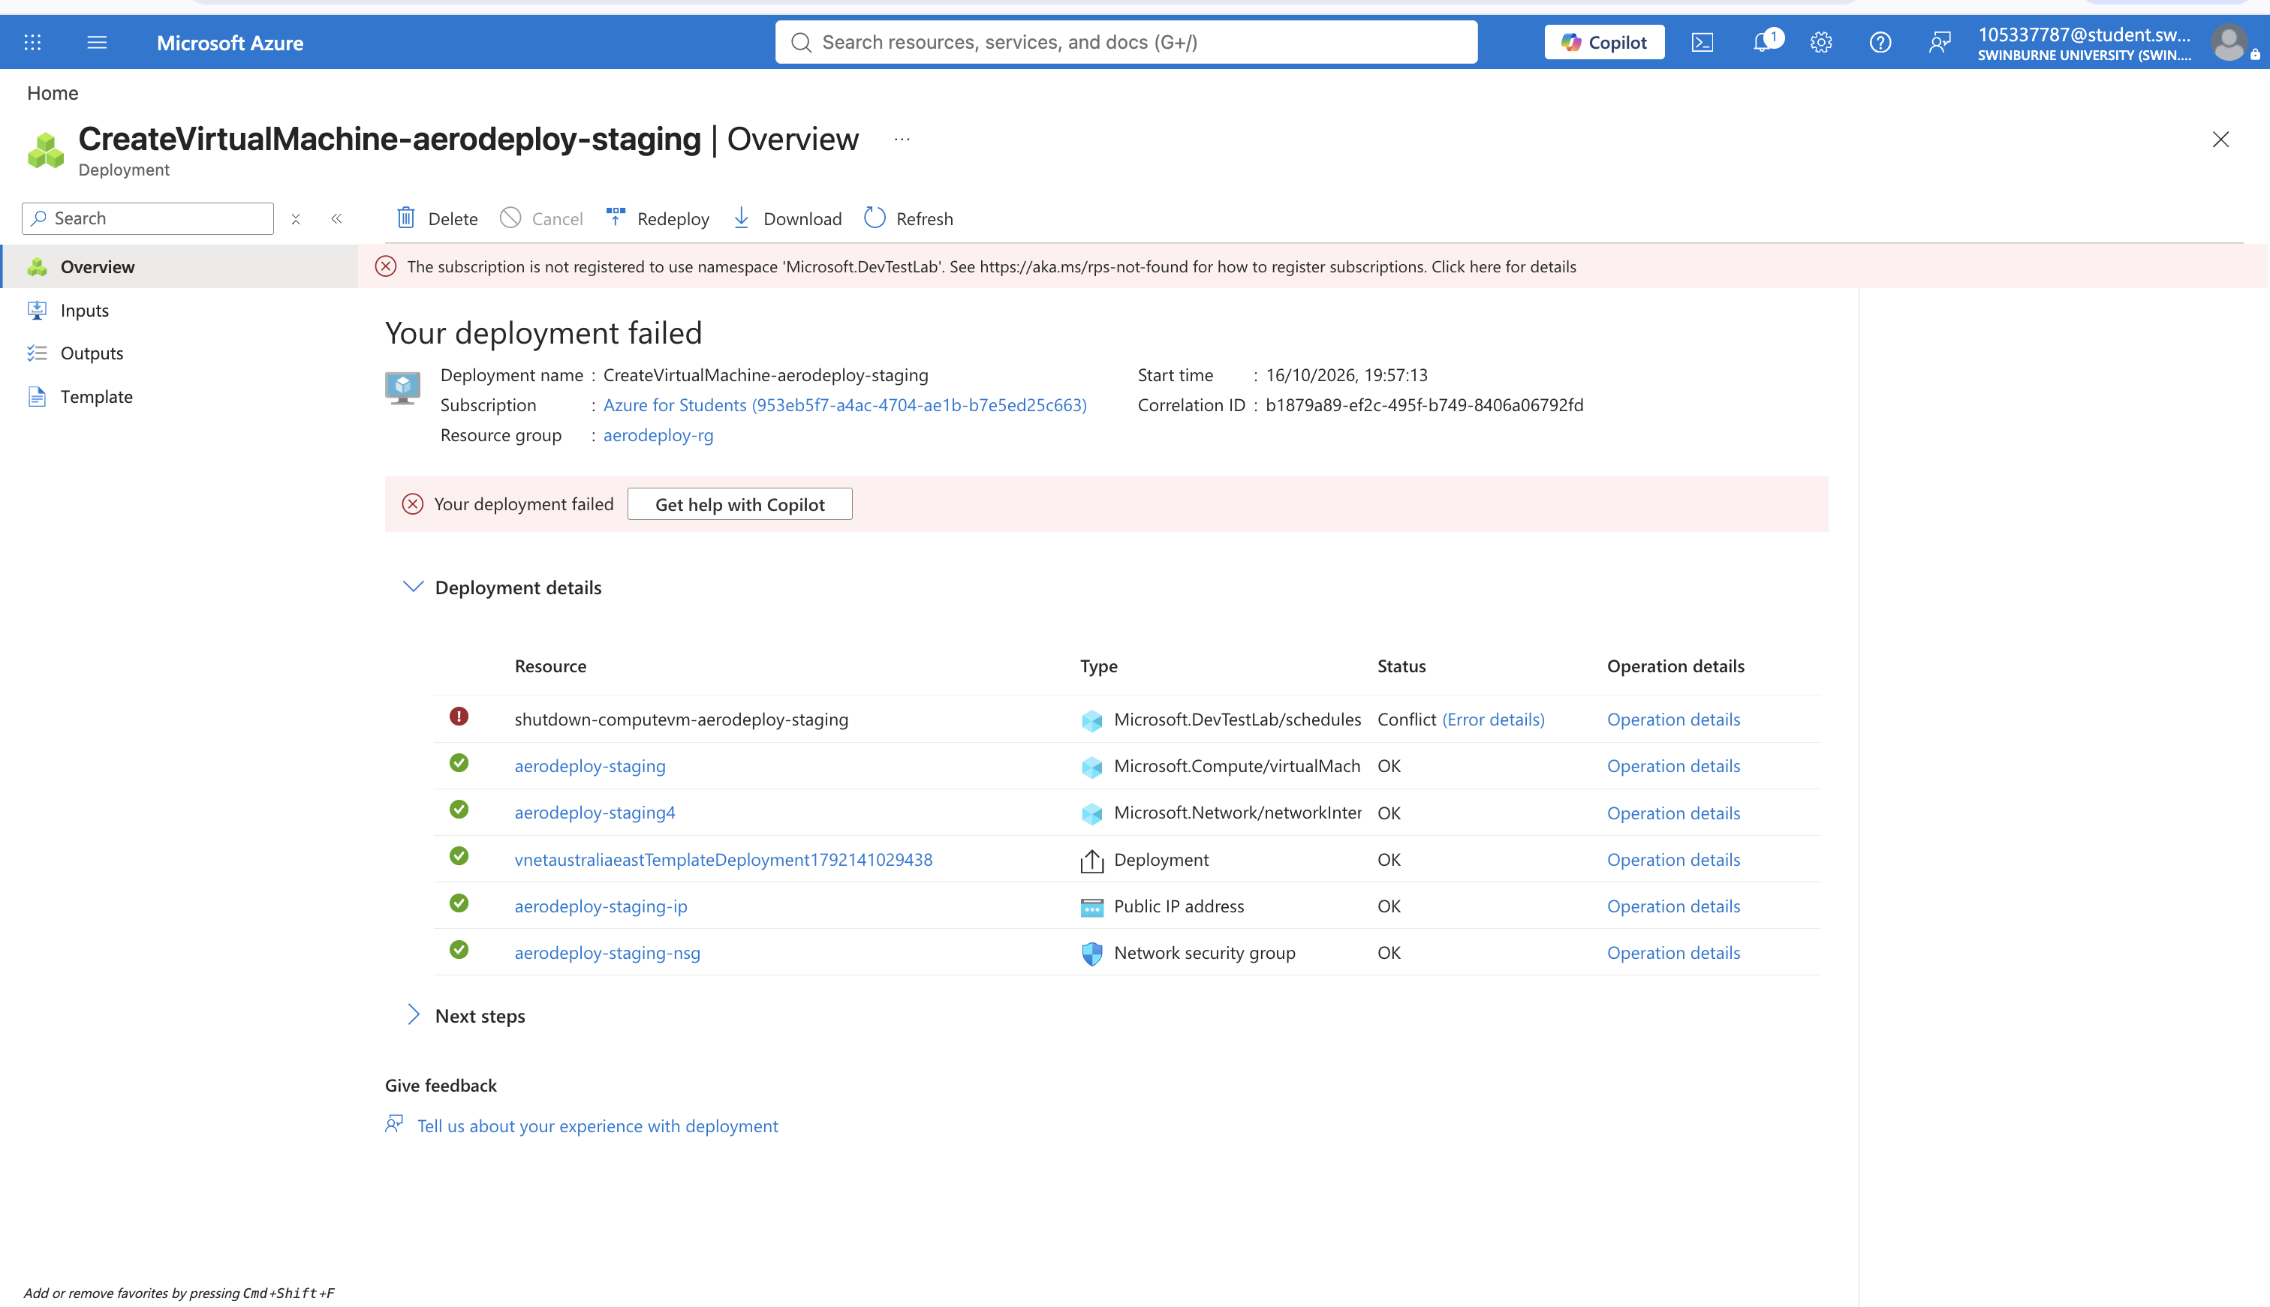
Figure X: Staging VM deployment showing the VM, network interface, public IP and security group created, with only the auto-shutdown schedule failing because Microsoft.DevTestLab was not registered.
Connection refused after reboot. SSH returned "Connection refused" immediately after the VM was restarted for a kernel update. The SSH service had not finished starting; retrying after about a minute succeeded.
Commands run on the wrong machine. After the connection was refused, the hello-world check was run on a team member's Mac instead of the VM; the output showed an arm64 image and Docker Compose v5.5.1 from Docker Desktop rather than the server's amd64 image and Compose 2.40.3. As the production team also found (Section 4.7), we checked that the terminal prompt showed the staging VM before running server commands.
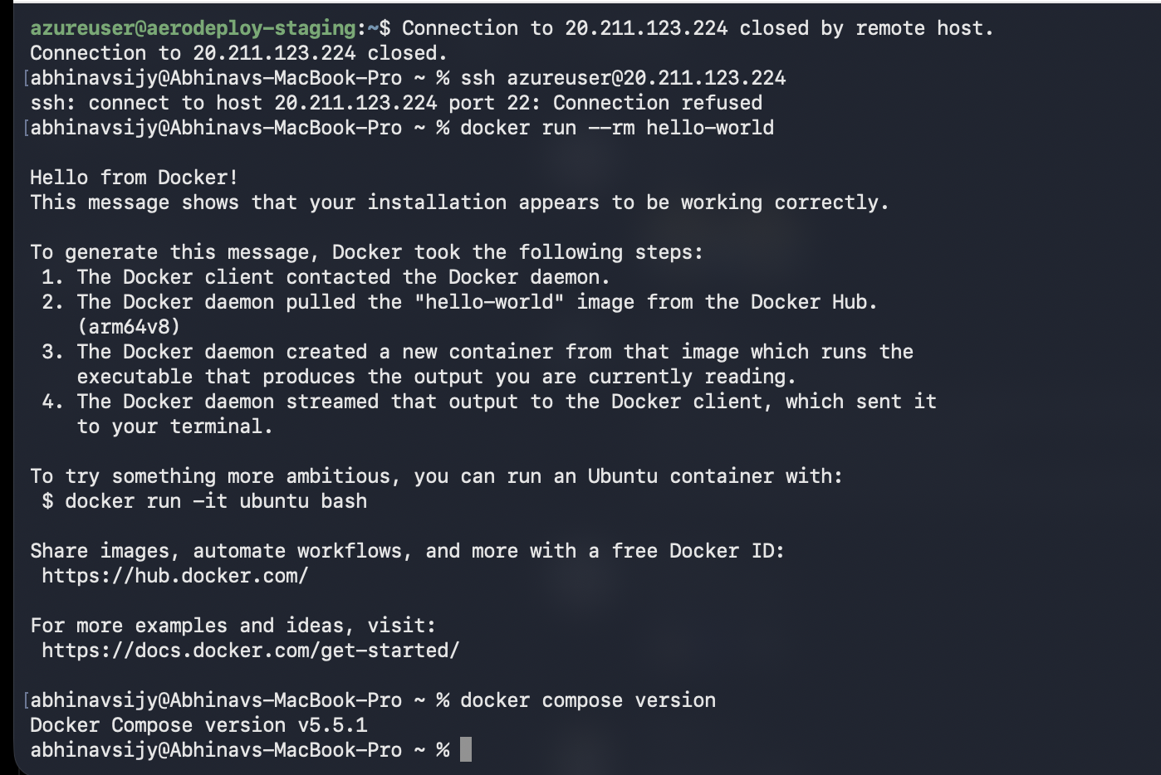
Figure X: SSH refused while the VM restarted, followed by hello-world accidentally run on the Mac (arm64, Compose v5.5.1).
Repository access. Cloning the private repository from the command line failed because GitHub does not accept account passwords for Git operations. We cloned it with GitHub Desktop, which authenticates through the browser.
Workflow file indentation. After the E2E step and the simulate_e2e_failure input were added to pipeline.yml, the new input was indented one level too deep, so it was nested under the existing input instead of being a separate option. We corrected the indentation and parsed the file to confirm that both inputs (simulate_failure and simulate_e2e_failure) were recognised before committing.
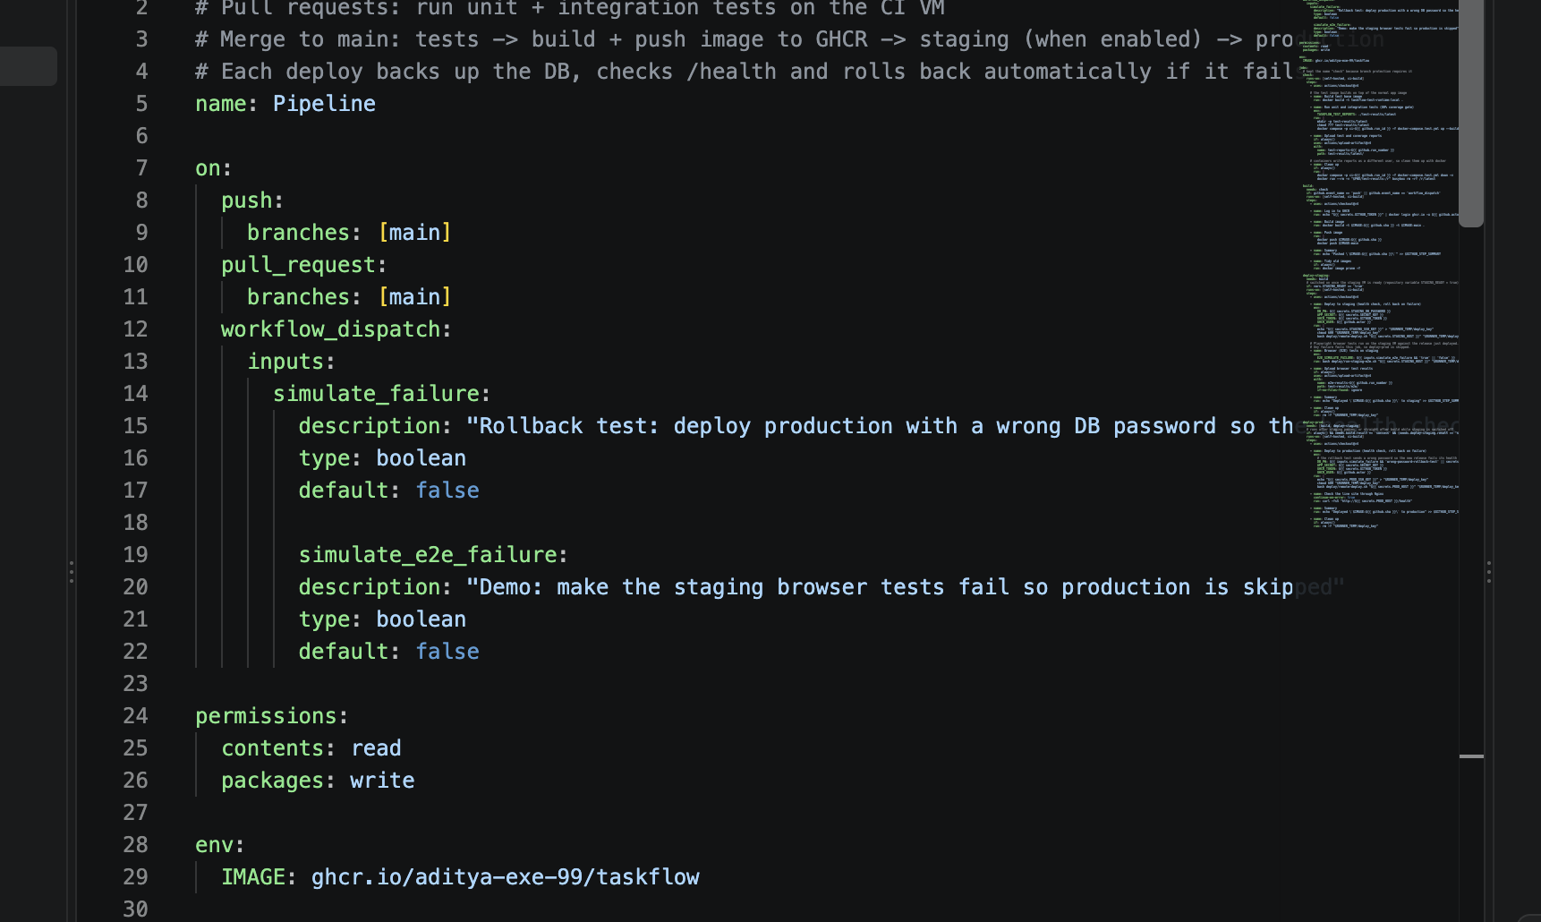
Figure X: The corrected workflow_dispatch inputs in pipeline.yml, with simulate_failure and simulate_e2e_failure at the same level.
Overly strict heading assertion. As described in Section 3.3, run #28 failed because the smoke test matched the dashboard heading exactly. The assertion was changed to check that the heading contains the title, and run #30 passed.

4.7 Production Deployment and Monitoring Troubleshooting
Unavailable VM sizes. When creating the production VM, the recommended sizes returned a NotAvailableForSubscription error because the Azure for Students subscription restricts which sizes can be used in Australia East. We opened the full size list and selected Standard_B2s_v2, which was available and met the memory needs of the application and monitoring stack.
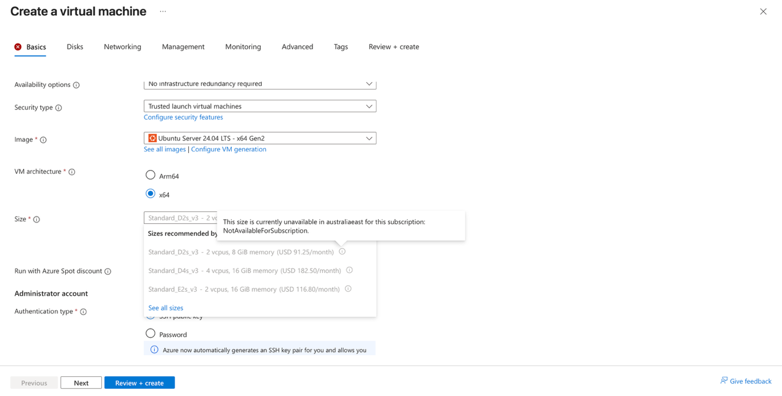Figure 13(a): VM size error during production VM creation.
SSH connection timeouts. Our first SSH attempt timed out. Checking the network security group showed that it had no inbound rules for ports 22 or 80, so all traffic was blocked by the default DenyAllInBound rule. We added Allow-SSH and Allow-HTTP rules, after which the connection succeeded. Later, SSH timed out again because our public IP address had changed
when working from a different network, and the SSH rule only allowed the old address. We identified the new address with curl ifconfig.me and updated the source IP of the SSH and Grafana rules. This recurred on 26 October and was resolved the same way.
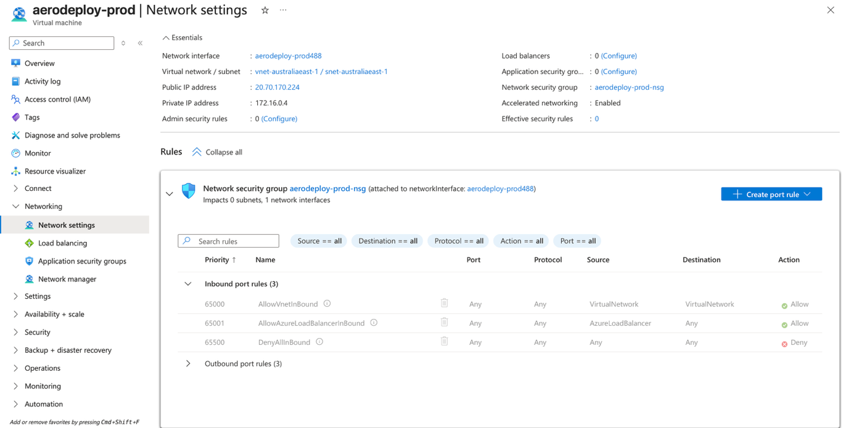Figure 13(b): Network security group with no SSH or HTTP rules.
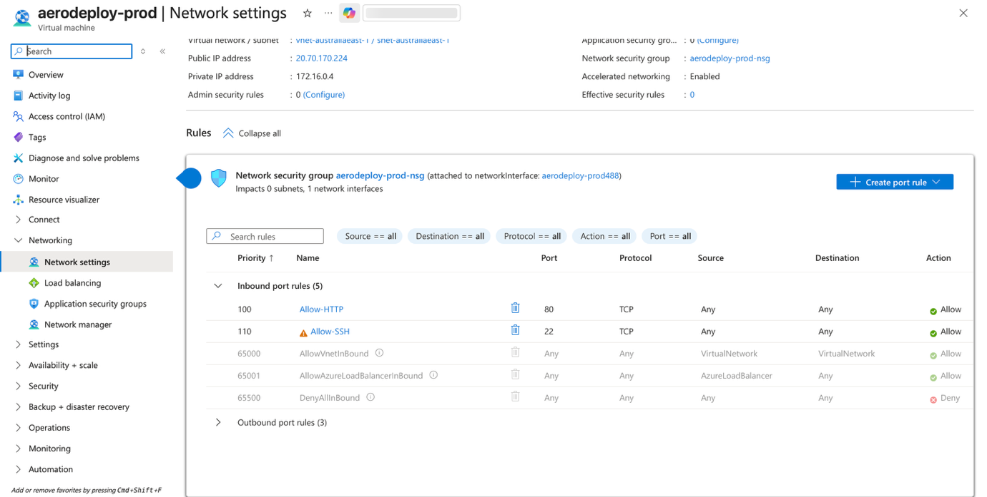Figure 13(c): Network security group after adding the Allow-SSH and Allow-HTTP rules.
Commands run in the wrong environment. Several errors, including “apt: command not found”, “Cannot connect to the Docker daemon” and “Identity file not accessible”, occurred because commands intended for the VM were run on a laptop or in Azure Cloud Shell. We resolved this by checking that the terminal prompt showed azureuser@aerodeploy-prod before running server commands. Where a command had to be run from Cloud Shell, we used az vm run-command, adding the --subscription option after an AuthorizationFailed error caused by Cloud Shell defaulting to a different subscription.
Grafana login failure. The first Grafana login failed with “Invalid username or password” because the password had been mistyped. We re-entered the credentials and, where needed, reset the administrator password using Grafana’s command-line tool.
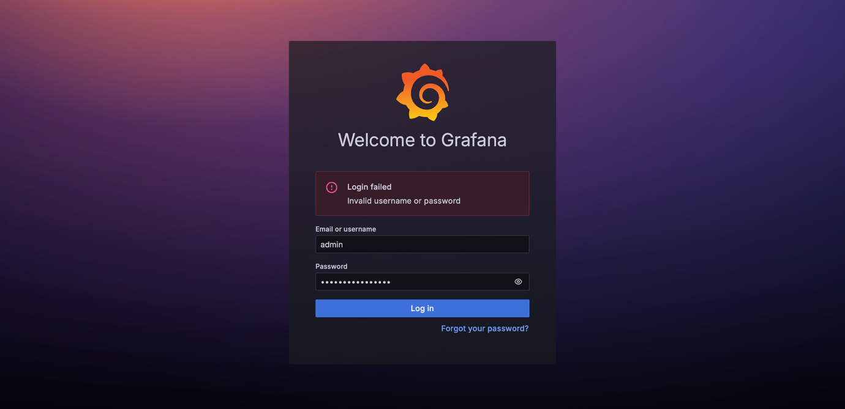Figure 13(d): Failed Grafana login.
Prometheus could not reach the application. After the first deployment, Prometheus reported the taskflow target as down. The monitoring stack and the application ran in separate Docker Compose projects and were therefore on different Docker networks. We connected Prometheus to the application’s network (aerodeploy-taskflow_default), after which the target reported as up.
Error-rate panel showed “No data”. The error-rate panel was empty because its query returned no result when there were no server errors. We added or vector(0) to the query so that the panel shows 0% instead.
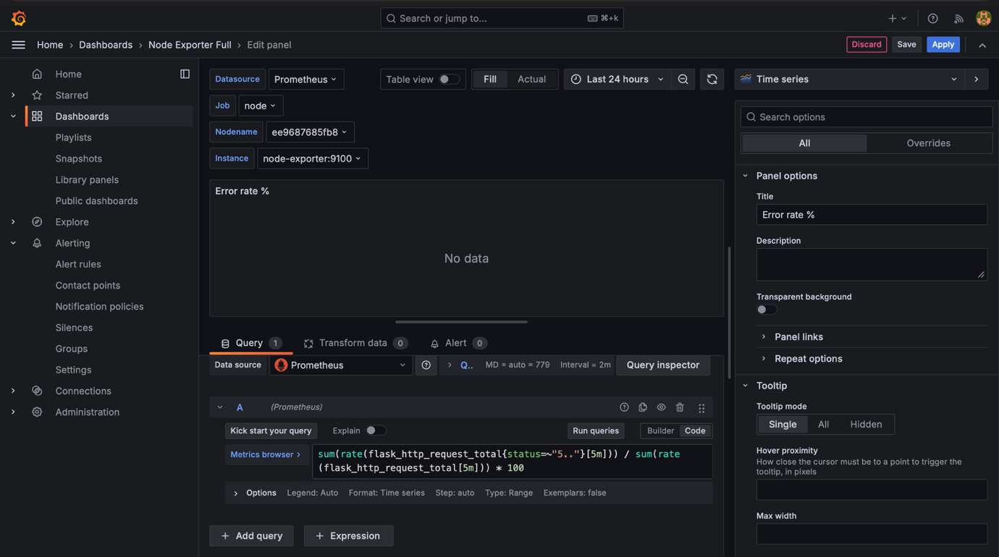Figure 13(e): Error-rate panel showing “No data” before the query was corrected.
Persistence test table missing. On 26 October, the persist_test table could not be found in the production database. Investigation showed that the persistence test had been run on the initial manually deployed database. When the pipeline took over deployments, it created a new database container and volume under the aerodeploy-taskflow project name, so the earlier test data was not carried over. This is unresolved: the persistence test should be repeated on the pipeline-managed database.
Outstanding issues. HTTPS, alert notifications, load testing and a week-long uptime measurement have not yet been completed. These are discussed in Section 5.6.

4.8 Outstanding Team Issues and Resolution Status

5. Project Outcomes & Reflections

5.1 Application Development and Local Verification Outcomes
We developed a working TaskFlow application with project and task management, input validation, dashboard summaries and deletion confirmations. The application runs locally with separate Docker containers for Flask and PostgreSQL. Database migrations prepare the schema during startup, and the health endpoint checks database availability.
Local checks confirmed that stored records remained available after service restart and container recreation, as shown in Figure 13. Manual browser checks also covered the main workflows and selected mobile layouts. The final automated run passed 48 test methods and 95 subtests, achieving 99.64% application statement coverage against the 80% requirement, as shown in Figure 14.
The application, container configuration, migrations, tests and handover documentation were reviewed and merged into the team repository through pull request #1. This provided the application foundation for integration with the team’s deployment pipeline.

5.2 Lessons Learned from Application Development
We learned to check the main application pages alongside container health. The Projects page error occurred while the containers were healthy, showing why route and browser checks were necessary after application changes.
The permission issues helped us understand the requirements of running containers as a non-root user. Checking startup logs allowed us to correct the Gunicorn configuration and dependency-export warning while retaining the restricted account.
The failed deletion test also showed that the order of test requests matters. We corrected when the temporary success message was checked while keeping the database-deletion checks in place. Preserving screenshots, complete terminal output and test reports made the final results easier to explain and verify.

5.3 Scope of the Current Results
The completed checks demonstrate local application behaviour and provide a repeatable setup for the team. The coverage result measures Python statements exercised by the tests; browser workflows and deployment behaviour require their own checks. The persistence tests demonstrate survival across container replacement, while backup restoration remains a separate operational check.
The following sections will record the team’s server-based results and overall pipeline evaluation.

5.4 Test/Staging and End-to-End Acceptance Outcomes
The Test/Staging environment met its main goals. A separate staging VM runs the same container image as production with its own PostgreSQL database, can be reached only by the pipeline, and receives every release automatically after the build job. Eight Playwright acceptance tests run against each staging deployment and act as a gate: production is deployed only when all of them pass. The gate was demonstrated both deliberately, using the simulate_e2e_failure option, and by a real change in run #28, where production was not updated until the test was corrected in run #30.
The version test also confirms that staging is running the exact commit being promoted. This supports the build-once, promote approach, because the image tested on staging is the same image later deployed to production.
Some limitations remain. The tests use only Chromium, cover the main user journeys rather than every page, and do not measure performance under load. The unit and integration tests run on the CI/Build server rather than against the staging deployment. Run #28 also showed that tests matching exact page text can fail on harmless wording changes, so assertions should check the essential content rather than exact strings.
Future improvements include running the tests in Firefox and WebKit, adding accessibility and visual-change checks, and running a short load test against staging before each release is promoted.

5.5 Pipeline Automation and Performance Evaluation

5.6 Production Deployment, Monitoring and Reliability Outcomes
The production environment met its main goals. TaskFlow is served publicly through Nginx with a healthy application and database, and Prometheus and Grafana monitor server and application performance; on 20 October the application had a 0% error rate and a p95 response time of about 5 milliseconds. The HighCPU alert was tested end to end, and nightly backups run automatically with a successful restore test.
Some limitations remain. The site does not yet use HTTPS, backups are stored on the same VM, alerts do not send notifications, and no load test was completed. Future work includes adding a Let’s Encrypt certificate, copying backups to separate storage, adding Alertmanager notifications and repeating the persistence test on the pipeline-managed database.

5.7 Overall Team Reflection and Future Improvements

6. Link to Project Repository
The project source code is maintained in the team’s GitHub repository:
https://github.com/AdityA-exe-99/taskflow
The application contribution was reviewed and merged into the main branch through pull request #1. It includes the Flask application, Docker and PostgreSQL configuration, database migrations, automated unit and integration tests, and setup and handover documentation.
The repository provides the application and configuration files supporting the implementation described in this report.

References
[Insert the sources actually used and cited, formatted according to the unit’s required referencing style.]

Appendix A: Selected Local Application Logs
This appendix contains selected results from the local development checks recorded on 11–12 October 2026. Each entry identifies its supporting figures. Where a transcript omitted output, the relevant screenshot was used for transcription.
Personal prompt paths, repetitive progress output and unrelated lines are omitted. Column spacing is adjusted where needed. Separate blocks represent separate checks, and any abbreviation within an error message is labelled.

A.1 Development Environment and Workspace
Supports Figures 3–4 and Section 3.1.
The environment check confirmed the required tools and access to Docker Desktop’s Linux engine.
git --version
git version 2.53.0.windows.1

py --version
Python 3.13.7

docker --version
Docker version 29.7.2, build a7dcaa6

docker compose version
Docker Compose version v5.5.1

docker info --format 'Server version: {{.ServerVersion}} | OS: {{.OperatingSystem}} | Container type: {{.OSType}}'
Server version: 29.7.2 | OS: Docker Desktop | Container type: linux
The directory listings in Figure 4 confirmed the initial workspace. The following extracts retain only the relevant directory-name columns.
Project root directories:
app
deploy
docs
tests
Directories within tests:
e2e
integration
unit
These listings record the initial organisation of the workspace; directory creation alone does not demonstrate implemented tests or deployment configuration.

A.2 Container Runtime and Build
Supports Figure 7 and Section 3.3.
The runtime output confirms Python 3.12.15 and execution under the non-root application account.
docker compose exec -T web python --version
Python 3.12.15

docker compose exec -T web id
uid=999(taskflow) gid=999(taskflow) groups=999(taskflow)

The recorded build used the following command:
docker compose up --build --wait --wait-timeout 180

Selected build and completion lines from Figure 7(c) are reproduced below. Progress symbols and timing columns are omitted.
[7/8] COPY --chown=taskflow:taskflow migrations ./migrations
[8/8] COPY --chown=taskflow:taskflow docker-entrypoint.py ./docker-entrypoint.py

Image aerodeploy-taskflow-web Built
Container aerodeploy-taskflow-db-1 Healthy
Container aerodeploy-taskflow-web-1 Healthy

A.3 Database Schema and Automatic Migration
Supports Figure 8 and Section 3.3.
The migration-status check and PostgreSQL table listing in Figure 8(a) returned:
41a8c3c36f29 (head)
Schema | Name | Type | Owner
--------+-----------------+-------+----------
public | alembic_version | table | taskflow
public | projects | table | taskflow
public | tasks | table | taskflow
(3 rows)
The fresh-environment check in Figure 8(b) recorded successful startup:
Fresh database startup exit code: 0
Its application log shows the migration completing before Gunicorn started.
web-1 | Applying database migrations...
web-1 | INFO [alembic.runtime.migration] Context impl PostgresqlImpl.
web-1 | INFO [alembic.runtime.migration] Will assume transactional DDL.
web-1 | INFO [alembic.runtime.migration] Running upgrade -> 41a8c3c36f29, Create projects and tasks
web-1 | Database migrations complete. Starting Gunicorn.
web-1 | [2026-10-12 05:40:29 +0000] [1] [INFO] Starting gunicorn 26.2.0

A.4 Local Metrics Endpoint
Supports Figure 6 and Section 3.2.
Selected output from the saved metrics capture confirms request-duration measurements and counters labelled by endpoint, method and response status.
flask_http_request_duration_seconds_count{endpoint="index",method="GET",status="200"} 1.0
flask_http_request_duration_seconds_sum{endpoint="index",method="GET",status="200"} 0.006614193000132218
# HELP taskflow_requests_total Request count by endpoint, method and status
# TYPE taskflow_requests_total counter
taskflow_requests_total{endpoint="health",method="GET",status="200"} 3104.0
taskflow_requests_total{endpoint="index",method="GET",status="200"} 1.0
taskflow_requests_total{endpoint="prometheus_metrics",method="GET",status="200"} 1.0

These are local observations. The health-check counter includes automated probes and does not represent user traffic or production load.

A.5 Database Recovery and Persistence
Supports Figures 12–13 and Section 3.3.
Figure 12 records the health response while PostgreSQL was stopped and after recovery. Selected response lines are transcribed below; other HTTP headers are omitted.
Database stopped:
HTTP/1.1 503 SERVICE UNAVAILABLE

{"db":"unavailable","status":"error"}
Database recovered:
HTTP/1.1 200 OK

{"db":"ok","status":"ok"}
The same query result appears before restart, after restart and after container recreation in Figures 13(a), 13(b) and 13(d). Column spacing is adjusted below.
project_id | name | task_id | title | status | priority | due_date
1 | Persistence check | 1 | Retain task after restart | in_progress | high | 2026-10-19
(1 row)
The recreation transcript records exit code 0 and different database container identifiers:
Recreation exit code: 0
Database container before: b042ada393d5d519c67764eac3621b38f7f3a280236086b9926ddfdbfc045dbf
Database container after: 968cf1c2c655a24252bf51c0e104940ed418d56dadda65f2cb75991fd7fb1377
Together, these records demonstrate persistence across restart and container replacement while retaining the database volume.

A.6 Automated Application Tests and Coverage
Supports Figure 14 and the application checks described in Section 3.3.
The final run included validation, project and task operations, navigation, dashboard behaviour and supporting endpoints. Selected passing results are shown below. Common container, file and class prefixes are omitted; test names and results are retained.
test_task_title_is_required PASSED [ 25%]
test_dashboard_updates_after_overdue_task_is_completed PASSED [ 45%]
test_every_write_route_rejects_missing_and_incorrect_csrf PASSED [ 58%]
test_health_checks_the_real_test_database PASSED [ 60%]
test_navigation_and_all_existing_record_pages_render PASSED [ 81%]
test_project_creation_persists_trimmed_fields_and_redirects PASSED [ 83%]
test_task_creation_persists_every_field PASSED [ 89%]
test_task_delete_removes_only_selected_task PASSED [ 93%]
test_task_edit_persists_fields_and_can_clear_due_date PASSED [ 95%]
test_user_text_is_escaped_in_rendered_pages PASSED [100%]

The final coverage table and test summary were:
tests-1 | Name Stmts Miss Cover Missing
tests-1 | --------------------------------------------------
tests-1 | app/__init__.py 44 1 97.73% 19
tests-1 | app/extensions.py 7 0 100.00%
tests-1 | app/models.py 26 0 100.00%
tests-1 | app/validation.py 44 0 100.00%
tests-1 | app/views.py 155 0 100.00%
tests-1 | --------------------------------------------------
tests-1 | TOTAL 276 1 99.64%
tests-1 | Coverage HTML written to dir /app/test-results/html
tests-1 | Coverage XML written to file /app/test-results/coverage.xml
tests-1 | Required test coverage of 80% reached. Total coverage: 99.64%
tests-1 | ==================== 48 passed, 95 subtests passed in 4.21s ====================
tests-1 exited with code 0
Later lines in the same capture confirm successful execution and cleanup.
Test and coverage exit code: 0
Test cleanup exit code: 0
The generated JUnit XML, coverage XML and HTML coverage report were retained with the evidence. These results establish local automated testing. Figures 9–11 separately document manual browser checks; they are not automated end-to-end acceptance tests.

A.7 Troubleshooting and Retesting
Supports Figures 15–19 and Section 4.
Missing SECRET_KEY — Figure 15
The configuration check reported the missing setting and returned exit code 1.
error while interpolating services.web.environment.SECRET_KEY: required variable SECRET_KEY is missing a value: Set SECRET_KEY in .env
After adding the setting, the repeated check returned exit code 0.
docker compose config --quiet
echo $LASTEXITCODE
0
Gunicorn control-server permissions — Figure 16
The original startup log contained:
web-1 | [2026-10-12 05:27:39 +0000] [1] [ERROR] Control server error: [Errno 13] Permission denied: '/home/taskflow'
After disabling the unused control socket, Figure 16(b) records startup without recurrence of that error. Selected startup lines were:
web-1 | [2026-10-12 05:31:56 +0000] [1] [INFO] Starting gunicorn 26.2.0
web-1 | [2026-10-12 05:31:56 +0000] [1] [INFO] Listening at: http://0.0.0.0:8000 (1)
Pip cache permissions — Figure 17
The first two sentences of the recorded warning were:
WARNING: The directory '/home/taskflow/.cache/pip' or its parent directory is not owned or is not writable by the current user. The cache has been disabled.
The corrected export command disabled caching:
docker compose exec -T web pip --no-cache-dir freeze | Set-Content -Encoding ascii requirements-lock.txt
Figure 17(b) shows the resulting dependency file. Selected package entries were:
Flask==3.1.3
Flask-Migrate==4.1.0
Flask-SQLAlchemy==3.1.1
gunicorn==26.2.0
SQLAlchemy==2.0.54
Projects page rendering — Figure 18
The browser screenshot preserves the HTTP 500 failure. The original traceback is not retained in the available transcript. After editing the view code, the recorded syntax and rebuild checks returned exit code 0.
py -m py_compile app\views.py
echo $LASTEXITCODE
0

docker compose -p aerodeploy-taskflow up --build --wait --wait-timeout 180
echo $LASTEXITCODE
0
The successful browser workflow in Figure 10 and the passing page-rendering test in Appendix A.6 provide subsequent verification.
Project-deletion assertion — Figure 19
The earlier run failed while checking the one-time success message. The returned HTML is omitted as labelled.
tests-1 | self.assertIn(b"Project deleted successfully.", response.data)
tests-1 | AssertionError: b'Project deleted successfully.' not found in [HTML response omitted for readability]
tests-1 |
tests-1 | ----------------------------------------------------------------------
tests-1 | Ran 48 tests in 1.014s
tests-1 |
tests-1 | FAILED (failures=1)
tests-1 exited with code 1
The request order was corrected while retaining the database-deletion checks. The final passing suite is recorded in Appendix A.6.

A.8 Repository Checks and Handover
Supports Figure 5 and Sections 3.1 and 4.5.
The staged whitespace check initially identified an issue in the migration file:
git diff --cached --check
migrations/versions/41a8c3c36f29_create_projects_and_tasks.py:4: trailing whitespace.
+Revises:
After correction and staging, the repeated check produced no output. The subsequent commit returned:
[feature/taskflow-application b84b39d] Add TaskFlow application, containers and automated tests
36 files changed, 3118 insertions(+), 2 deletions(-)
The push output confirmed publication of the feature branch:
To https://github.com/AdityA-exe-99/taskflow.git
* [new branch] feature/taskflow-application -> feature/taskflow-application
branch 'feature/taskflow-application' set up to track 'origin/feature/taskflow-application'.

Figure 5 provides the subsequent evidence that pull request #1 was reviewed and merged into main. The local logs in this appendix do not establish execution on the team’s Test/Staging or Production servers.

Appendix B: Selected Production and Monitoring Logs
This appendix contains selected outputs from the production VM, recorded on 26 October 2026. Prompts and unrelated lines are omitted.

B.1 Production Server Setup
Supports Figure 6 and Section 3.1.
The version checks confirm that Docker and Docker Compose are installed on the production VM.
docker --version
Docker version 29.9.0, build f415da8
docker compose version
Docker Compose version v5.6.0

B.2 Access Controls
Supports Figure 7 and Section 3.1.
The output confirms that the deploy user used by the pipeline belongs to the docker group.
id deploy
uid=1001(deploy) gid=1001(deploy) groups=1001(deploy),100(users),988(docker)

B.3 Monitoring Configuration
Supports Figure 8 and Section 3.2.
All three monitoring containers are running, and Prometheus is bound to 127.0.0.1 so it cannot be reached from the internet.
docker compose ps (selected columns)
monitoring-grafana-1 grafana/grafana:11.1.0 Up 0.0.0.0:3000->3000/tcp
monitoring-node-exporter-1 prom/node-exporter:v1.8.1 Up 9100/tcp
monitoring-prometheus-1 prom/prometheus:v2.53.0 Up 127.0.0.1:9090->9090/tcp

B.4 Alert Rules
Supports Figure 10 and Section 3.2.
The alert rules define the limits for CPU, memory, disk and application availability.
cat ~/monitoring/alerts.yml (summary lines only)
summary: CPU above 80% for 5 minutes
summary: RAM above 80% for 5 minutes
summary: Disk above 85%
summary: TaskFlow /metrics has not responded for 1 minute

B.5 Live Application Verification
Supports Figure 11 and Section 3.3.
The health check, made through Nginx from outside the VM, confirms that the application and database are healthy.
curl -i http://20.70.170.224/health
HTTP/1.1 200 OK
Server: nginx/1.24.0 (Ubuntu)
{"db":"ok","status":"ok"}

B.6 Database Backups
Supports Figure 12 and Section 3.3.
The cron job runs the backup script nightly at 16:00 UTC, and seven daily backups are retained.
crontab -l
0 16 * * * /home/azureuser/backup-db.sh
ls -lh ~/backups (file names only)
taskflow_2026-10-19.sql ... taskflow_2026-10-25.sql (7 files)

